Veteran Health Identification Card (VHIC 4.8)

**User Guide**



Volume 1 - Card Request – All Users

January 2018

Department of Veterans Affairs

Office of Information and Technology (OI&T)

Revision History

NOTE: The revision history cycle begins once changes or enhancements are requested after the document has been baselined.

|  |  |  |  |
| --- | --- | --- | --- |
| Date | Revision | Description | Author |
| 01/19/2018 | 2.1 | Re-paginated document. Readied document for creating Section 508 compliant PDF. | Donnie Canham |
| 01/17/2018 | 2.1 | Applied change from third anomaly log dated 011718 and e-mail direction from same date. | Donnie Canham |
| 01/16/2018 | 2.1 | Applied changes from second anomaly log dated 011618. | Donnie Canham |
| 01/12/2018 | 2.1 | Applied changes from first anomaly log dated 010418. | Donnie Canham |
| 12/28/2017 | 2.1 | Updated document images to include “Skip to Content” link where necessary. Re-ran TOCs, added Alt Text to all images and figures, and changed document date from “August 2017” to “January 2018.” Updated Appendix entitled “VHIC Roles.” | Donnie Canham |
| 08/17/2017 | 2.0 | After receiving documentation updates, re-completed steps from 08/08/17 Revision History entry. Also, fixed figure numbering transition between Figure 2-10 and Figure 2-12. | Donnie Canham |
| 08/08/2017 | 2.0 | Added Alt text to all images and figures. Accepted all changes remaining in document, re-ran TOCs, and fixed content/figure pagination issues in the Word document. Revision History number set to “2.0” and document converted to Section 508 compliant PDF as part of VHIC 4.8. | Donnie Canham |
| 07/21/2017 | 2.0 | Updated to include standard image for “Veteran Image.” | Donnie Canham |
| 07/18/2017 | 2.0 | Updated with content and images for first draft for VHIC 4.8. | Donnie Canham |
| 04/15/2017 | 1.7 | Updated for VIP 2 Changes | Dawn Bryant |
| 08/12/2016 | 1.6 | Completed technical writer review of document. Ran Spelling and Grammar, added Alt text to all images, and re-ran TOCs. | Donnie Canham |
| 08/10/2016 | 1.6 | Updated content and Images for VHIC 4.7 | Laja Geno |
| 01/06/2016 | 1.5 | Updated content and Images | Laja Geno |
| 07/07/2015 | 1.4 | Updated content and Images | Laja Geno |
| 07/07/2015 | 1.3 | Rebuilt to capture content overhaul to VHIC System and divided this guide into three separate parts | Laja Geno |
| 05/20/2015 | 1.2 | Updated Content and Images to reflect the Maintenance Releases | Laja Geno |
| 01/13/2015 | 1.1 | Updated content and Images | Laja Geno |
| 09/18/2014 | 1.0 | Rebuilt to capture content overhaul to VHIC System | Michele Custis |

**Table of Contents**

1. Introduction 1

1.1. Purpose 1

1.2. Document Orientation 1

1.2.1. Organization of the Manual 1

1.2.2. Assumptions 2

1.2.3. Disclaimers 2

1.2.3.1. Software Disclaimer 2

1.2.3.2. Documentation Disclaimer 2

1.2.4. Documentation Conventions 3

1.3. Enterprise Service Desk and Organizational Contacts 3

2. Veteran Health Identification Card – What is it? 4

2.1. Accessing the VHIC Application 4

2.2. Browser 5

2.2.1. Browser Incompatibility Issue 5

2.3. Proper Navigation of the VHIC Application 10

2.4. Roles within VHIC 10

2.4.1. VHIC Associate 11

2.4.2. VHIC Supervisor 11

2.4.3. VHIC Administrator 11

2.4.4. VHIC Technical Administrator (Tier 3) 11

2.4.5. VHIC Auditor 11

2.4.6. VHIC Read-Only User 11

3. Getting Started 12

3.1. Single Sign-On Internal (SSOi) 12

3.2. Logging On 12

3.3. System Menu 13

3.3.1. VHIC Administrator and Technical Administrator Tier 3 13

3.3.2. VHIC Associate and Supervisor 14

3.3.3. VHIC Auditor and Read-Only User 15

3.4. Changing User ID and Password 15

4. Proofing Veteran before Requesting a VHIC Card 15

4.1. Accessing the Identity Management Toolkit 15

4.1.1. Accessing the Identity Management Toolkit Directly 15

4.1.1.1. SSOi 16

4.1.2. Accessing Identity Management Toolkit from within the VHIC Application 16

4.1.2.1. Step 1 of the VHIC Application 16

4.1.2.2. Step 5 of the VHIC Application 17

4.1.3. Logging out of Identity Management Toolkit 18

4.2. Proofing Process and Steps 19

4.2.1. Looking up the Veteran 19

4.2.1.1. Quick Search 20

4.2.1.2. Person Search 22

4.2.2. Primary View 25

4.2.3. If Level of Assurance is Level 1 – Complete Proofing 26

4.2.4. If Level of Assurance is Level 2 – Continue to Issue VHIC 35

5. Creating a VHIC Card – The Card Request Process 36

5.1. New VHIC: Veteran Level 2 Proofed through Identity Management Toolkit 37

5.1.1. Step 1: Enter Search Terms 37

5.1.2. Step 2: Select Veteran 39

5.1.3. Step 3: Capture Veteran Image 40

5.1.3.1. Take New Picture 41

5.1.3.2. Upload from File 44

5.1.3.3. Reuse Existing Image 48

5.1.4. Step 4: Select Mailing Address 50

5.1.5. Status Section 51

5.1.6. Step 5: Save Card Request 52

5.1.6.1. Branch of Service 53

5.1.6.2. Save Card Request: New 54

5.2. New VHIC: Veteran has NOT been Level 2 Proofed through Identity Management Toolkit 55

5.2.1. Step 1: Enter Search Terms 55

5.2.2. Step 2: Select Veteran 57

5.2.3. Step 3: Capture Veteran Image 58

5.2.3.1. Take New Picture 59

5.2.4. Step 4: Select Mailing Address 62

5.2.5. Status Section 64

5.2.6. Step 5: Save Card Request 65

5.2.6.1. Branch of Service 66

5.2.6.2. Save Card Request: New 67

5.3. Resuming an On-Hold VHIC Request: Veteran NOT Level 2 Proofed Hold Reason 69

5.3.1. Step 1: Enter Search Terms 69

5.3.2. Step 2: Select Veteran 71

5.3.3. Reuse Existing Image 72

5.3.4. Step 4: Select Mailing Address 74

5.3.5. Status Section 75

5.3.6. Step 5: Save Card Request 75

5.3.6.1. Branch of Service 76

5.4. Replacement VHIC: Veteran Level 2 Proofed through Identity Management Toolkit 79

5.4.1. Step 1: Enter Search Terms 79

5.4.2. Step 2: Select Veteran 81

5.4.3. Step 3: Capture Veteran Image 82

5.4.3.1. Take New Picture 83

5.4.3.2. Upload from File 86

5.4.3.3. Reuse Existing Image 90

5.4.4. Step 4: Verify Identity Attributes 92

5.4.5. Status Section 94

5.4.5.1. Replacement Options 94

5.4.6. Step 5: Save Card Request 97

5.4.6.1. Branch of Service 98

5.4.6.2. Save Card Request: Replacement 99

5.5. Placing a Replacement VHIC Request On-Hold Manually: Veteran Level 2 Proofed 99

5.5.1. Step 1: Enter Search Terms 99

5.5.2. Step 2: Select Veteran 102

5.5.3. Reuse Existing Image 103

5.5.4. Step 4: Select Mailing Address 105

5.5.5. Status Section 107

5.5.5.1. Replacement Options 107

5.5.6. Step 5: Save Card Request 110

5.5.6.1. Save Card Request: Manually saved On-Hold 112

5.6. On Hold Reasons Explained 113

5.6.1. Veteran Not Proofed 113

5.6.2. Enrollment Services Unavailable 114

5.6.3. Eligibility Pending 115

5.6.4. Bad Data – Other 115

5.7. Resuming an On-Hold Replacement VHIC Request: Veteran Level 2 Proofed 116

5.7.1. Step 1: Enter Search Terms 116

5.7.2. Step 2: Select Veteran 118

5.7.3. Reuse Existing Image 119

5.7.4. Step 4: Select Mailing Address 120

5.7.5. Status Section 123

5.7.5.1. Replacement Options 123

5.7.6. Step 5: Save Card Request 126

5.8. Requesting a VHIC for a Veteran within ten (10) days of a previous VHIC request 129

6. Card Deactivations 130

7. Reports 130

8. Troubleshooting 130

Appendix A: VHIC Roles 131

**Table of Figures**

Figure 2‑1: Example of what the VHIC looks like 4

Figure 2‑2: Over-sized icon buttons on the Home Screen 5

Figure 2‑3: Words wrapping around the displayed photo on Step 3 5

Figure 2‑4: Content on the right of the Step 6 screen is shifted down 6

Figure 2‑5: Both the VISN and Facility selection lists are displayed and shifted to the right 6

Figure 2‑6: Internet Explorer's Toolbar Menu 7

Figure 2‑7: Tools Menu button 7

Figure 2‑8: Tools drop-down menu 8

Figure 2‑9: Compatibility View Settings screen 8

Figure 2‑10: Compatibility View Settings Screen - Close 9

Figure 2‑11: VHIC Administrator and VHIC Technical Administrator (Tier 3) menu 10

Figure 2‑12: VHIC Associate and VHIC Supervisor menu 10

Figure 2‑13: VHIC Auditor and VHIC Read-Only User menu 10

Figure 3‑1: SSOi Login Screen 12

Figure 3‑2: VHIC Administrator and VHIC Technical Administrator (Tier 3) Home screen 13

Figure 3‑3: VHIC Associate and VHIC Supervisor Home screen 14

Figure 3‑4: VHIC Auditor and VHIC Read-Only User Home screen 15

Figure 4‑1: Identity Management Toolkit SSOi Logon Screen 16

Figure 4‑2: Step 1: Enter Search Terms with Identity Management Toolkit hyperlink 17

Figure 4‑3: Step 5 - Save Card Request with Identity Management Toolkit hyperlink 18

Figure 4‑4: Log Off link located in the menu bar 18

Figure 4‑5: Log Off link located in the Navigation pane 18

Figure 4‑6: Identity Management Toolkit Idle message 19

Figure 4‑7: Identity Management Toolkit Search Screen 19

Figure 4‑8: Identity Management Toolkit Quick Search with Traits 20

Figure 4‑9: Identity Management Toolkit Quick Search - MVI Search Results 21

Figure 4‑10: Identity Management Toolkit Quick Search with ICN 21

Figure 4‑11: Identity Management Toolkit Search Screen; Click Search 22

Figure 4‑12: Identity Management Toolkit Search For Person screen 23

Figure 4‑13: Identity Management Toolkit Search For Person screen; Click Search 24

Figure 4‑14: Identity Management Toolkit Primary View Screen 25

Figure 4‑15: Tasks/Requests tab highlighted 26

Figure 4‑16: Tasks/Requests screen; click New Proofing Task 26

Figure 4‑17: Identification Confirmation Message 26

Figure 4‑18: Task Details screen; Click Person Verification 27

Figure 4‑19: Identity Management Toolkit Person Verification screen 27

Figure 4‑20: Verification Document Section; Select document type 28

Figure 4‑21: Verification Document Section; Enter document details 28

Figure 4‑22: Verification Document Section; Click Save Document Data 29

Figure 4‑23: Identity Management Toolkit Person Verification screen; Click Submit Verification 30

Figure 4‑24: Proofing verification in progress 31

Figure 4‑25: Task Complete Pop Up Message 31

Figure 4‑26: Person Verification Updated Message 32

Figure 4‑27: Identity Management Toolkit Primary View screen - Proofing Complete 32

Figure 4‑28: Refresh View button 32

Figure 4‑29: The Veteran's ICN is highlighted 33

Figure 4‑30: Step 1: Enter Search Terms - ICN has been entered 34

Figure 4‑31: The Veteran's ICN is highlighted 35

Figure 4‑32: Step 1: Enter Search Terms - ICN has been entered 35

Figure 5‑1: Card Request Navigation Bar 36

Figure 5‑2: Navigation Bar Step appearance by state 36

Figure 5‑3: Enter Search Terms screen 37

Figure 5‑4: Help icon 38

Figure 5‑5: Enter Search Terms screen 39

Figure 5‑6: Select Veteran screen 39

Figure 5‑7: Capture Veteran Image screen 40

Figure 5‑8: Capture Veteran Image screen – Take New Picture 41

Figure 5‑9: Capture Veteran Image screen – Capture Image 42

Figure 5‑10: Capture Veteran Image screen – Accept new photo; click Next 43

Figure 5‑11: Capture Veteran Image screen – Upload from File 44

Figure 5‑12: Capture Veteran Image screen – Upload photo; click Browse 45

Figure 5‑13: Capture Veteran Image screen – Upload photo; click Upload 46

Figure 5‑14: Capture Veteran Image screen – Edit photo; click Next 47

Figure 5‑15: Capture Veteran Image screen – Reuse Existing Photo; click Next 48

Figure 5‑16: Capture Veteran Image screen – Reuse Existing Photo; click OK 49

Figure 5‑17: Select Mailing Address screen 50

Figure 5‑18: Save Card Request review screen 52

Figure 5‑19: Branch of Service Selection 53

Figure 5‑20: New Card Request Submitted 54

Figure 5‑21: Help icon 55

Figure 5‑22: Enter Search Terms screen 56

Figure 5‑23: Select Veteran screen 57

Figure 5‑24: Step 3 - Capture Veteran Image screen 58

Figure 5‑25: Capture Veteran Image screen – Take New Picture 59

Figure 5‑26: Capture Veteran Image screen – Capture Image 60

Figure 5‑27: Capture Veteran Image screen – Accept new photo; click Next 61

Figure 5‑28: Select Mailing Address screen 63

Figure 5‑29: Save Card Request review screen 65

Figure 5‑30: Branch of Service Selection 66

Figure 5‑31: Card Request Saved on Hold – Veteran Not Proofed 68

Figure 5‑32: Help icon 69

Figure 5‑33: Enter Search Terms screen 70

Figure 5‑34: Select Veteran screen 71

Figure 5‑35: Capture Veteran Image screen – Reuse Existing Photo; click Next 72

Figure 5‑36: Capture Veteran Image screen – Reuse Existing Photo; click OK 73

Figure 5‑37: Select Mailing Address screen 74

Figure 5‑38: Branch of Service Selection 76

Figure 5‑39: Save Card Request review screen; click Submit 77

Figure 5‑40: Card Request Submitted 78

Figure 5‑41: Help icon 79

Figure 5‑42: Enter Search Terms screen 80

Figure 5‑43: Select Veteran screen 81

Figure 5‑44: Step 3 - Capture Veteran Image screen 82

Figure 5‑45: Capture Veteran Image screen – Take New Picture 83

Figure 5‑46: Capture Veteran Image screen – Capture Image 84

Figure 5‑47: Capture Veteran Image screen – Accept new photo; click Next 85

Figure 5‑48: Capture Veteran Image screen – Upload from File 86

Figure 5‑49: Capture Veteran Image screen – Upload photo; click Browse 87

Figure 5‑50: Capture Veteran Image screen – Upload photo; click Upload 88

Figure 5‑51: Capture Veteran Image screen – Edit photo; click Next 89

Figure 5‑52: Capture Veteran Image screen – Reuse Existing Photo; click Next 90

Figure 5‑53: Capture Veteran Image screen – Reuse Existing Photo; click OK 91

Figure 5‑54: Select Mailing address screen 92

Figure 5‑55: Card Request Status section 94

Figure 5‑56: Replacement Reason drop-down list 94

Figure 5‑57: Poor Quality Replacement Reasons 95

Figure 5‑58: Damaged Replacement Reasons 95

Figure 5‑59: Incorrect Information Replacement Reasons 96

Figure 5‑60: Save Card Request review screen 97

Figure 5‑61: Branch of Service Selection 98

Figure 5‑62: Replacement Card Request Submitted 99

Figure 5‑63: Help icon 100

Figure 5‑64: Enter Search Terms screen 101

Figure 5‑65: Select Veteran screen 102

Figure 5‑66: Capture Veteran Image screen – Reuse Existing Photo; click Next 103

Figure 5‑67: Capture Veteran Image screen – Reuse Existing Photo; click OK 104

Figure 5‑68: Select Mailing Address screen 105

Figure 5‑69: Card Request Status section 107

Figure 5‑70: Replacement Reason drop-down list 107

Figure 5‑71: Poor Quality Replacement Reasons 108

Figure 5‑72: Damaged Replacement Reasons 108

Figure 5‑73: Incorrect Information Replacement Reasons 109

Figure 5‑74: Save Card Request review screen 110

Figure 5‑75: Replacement Card Request Saved On Hold 112

Figure 5‑76: Veteran Not Proofed Warning message on Step 4: Select Mailing Address 113

Figure 5‑77: Reason for Hold: Veteran Not Proofed 113

Figure 5‑78: Card Request Status: On Hold - Veteran Not Proofed 114

Figure 5‑79: Reason for Hold: Enrollment Unavailable 114

Figure 5‑80: Reason for Hold: Eligibility Pending 115

Figure 5‑81: Reason for Hold: Bad Data – Name Spelled Wrong 115

Figure 5‑82: Card Request Status: Replacement on Hold - Bad Data: Name Spelled Wrong 116

Figure 5‑83: Reason for Hold: Bad Data Unchecked 116

Figure 5‑84: Help icon 117

Figure 5‑85: Enter Search Terms screen 117

Figure 5‑86: Select Veteran screen 118

Figure 5‑87: Capture Veteran Image screen – Reuse Existing Photo; click Next 119

Figure 5‑88: Capture Veteran Image screen – Reuse Existing Photo; click OK 120

Figure 5‑89: Select Mailing Address screen 121

Figure 5‑90: Card Request Status section 123

Figure 5‑91: Replacement Reason drop-down list 123

Figure 5‑92: Poor Quality Replacement Reasons 124

Figure 5‑93: Damaged Replacement Reasons 124

Figure 5‑94: Incorrect Information Replacement Reasons 125

Figure 5‑95: Save Card Request review screen; Uncheck Bad Data checkbox 126

Figure 5‑96: Save Card Request review screen; click Submit 127

Figure 5‑97: Replacement Card Request Submitted 128

Figure 5‑98: Replacement Card has been requested within the past 10 days 129

**Table of Tables**

Table 1: Documentation Symbols and Descriptions 3

Table 2: Enterprise Service Desk Contact Information 3

Table 3: Who can process a card request? 36

# Introduction

## Purpose

The purpose of this User Guide is to provide general system information, as well as accessibility and user roles with the VHIC application. This User Guide will provide a detailed walkthrough of creating a Veteran Health Identification Card request using the VHIC application. This User Guide will also provide the detailed steps on how VHIC Administrators can deactivate all of the VHICs associated to a selected Veteran.

## Document Orientation

### Organization of the Manual

This User Guide is divided into four sections to allow you to obtain quickly the information you need.

The first section will provide an overview of what a VHIC is and what the eligibility requirements are, and the various user roles and their accessibility within the VHIC application.

In order to be able to receive a VHIC, a Veteran must meet the following eligibility criteria:

* Be eligible for VA medical benefits
* Be enrolled in the VA Healthcare system
* Be Level 2 proofed at a VA medical facility
* Veteran identity must be recognized in the Master Veteran Index (MVI), which is managed by the Identity and Access Management (IAM) of the VA

***NOTE:*** *The level 2 proofing process is a method to verify the identity of Veterans. VA requires Veterans to provide approved identification documents to access Personal Identifiable Information (PII), Personal Health Information (PHI) and request a Veterans Health Identification Card (VHIC).*

The second and third sections will walk the user through the steps needed to access the VHIC application, as well as some general guidelines on using the VHIC application.

The fourth section will give the user step-by-step details of how to complete the Identity Proofing process before starting a card request for a Veteran. The VHIC user must verify the Veteran’s Identity Proofing Level is at Level 2 in the Identity Management Toolkit.

The fifth section explains the process involved with creating a VHIC for a Veteran. A step-by-step process will navigate the VHIC Associate through the screens in the VHIC application. Once all of the required information has been provided, the final step in the process will allow a VHIC request to be submitted for processing.

Each day, these card requests are transmitted from the VHIC system to a vendor to print and mail the cards to the Veterans, the preferred facility, or the requesting facility. Typically, the cards are received in 7-10 business days from date of request. To ensure the VHIC is received at the appropriate address, the VHIC Associate must verify that the correct address is used and the Print Vendor verifies that the address is valid. If the U.S. Postal Service cannot deliver the card, it is returned to the requesting facility.

The sixth section covers how to request card deactivation all of the VHICs for a specific Veteran.

The seventh section will provide information on the different reports available to VHIC Associates and the types of metrics that can be obtained.

The last section covers some troubleshooting issues and solutions that will help the VHIC user to better able to support the Veteran and ensure that the VHIC requests are processed properly.

### Assumptions

This guide has been written with the following assumed experience/skills of the audience:

* User has basic knowledge of the operating system (such as the use of commands, menu options, and navigation tools).
* User has been provided the appropriate active roles required for the VHIC application.
* User is using Internet Explorer to do their job of either Creating a VHIC Card Request, Running Reports, or Managing VHICs depending on user roles.
* User has validated access to the VHIC application.
* User has completed any prerequisite training.

### Disclaimers

#### Software Disclaimer

*This software was developed at the Department of Veterans Affairs (VA) by employees of the Federal Government in the course of their official duties. Pursuant to title 17 Section 105 of the United States Code this software is not subject to copyright protection and is in the public domain. VA assumes no responsibility whatsoever for its use by other parties, and makes no guarantees, expressed or implied, about its quality, reliability, or any other characteristic. We would appreciate acknowledgement if the software is used. This software can be redistributed and/or modified freely provided that any derivative works bear some notice that they are derived from it, and any modified versions bear some notice that they have been modified.*

#### Documentation Disclaimer

*The appearance of external hyperlink references in this manual does not constitute endorsement by the Department of Veterans Affairs (VA) of this Web site or the information, products, or services contained therein. The VA does not exercise any editorial control over the information you may find at these locations. Such links are provided and are consistent with the stated purpose of the VA.*

### Documentation Conventions

This manual uses several methods to highlight different aspects of the material.

* Various symbols are used throughout the documentation to alert the reader to special information. The following table gives a description of each of these symbols:

Table : Documentation Symbols and Descriptions

| **Symbol** | **Description** |
| --- | --- |
| Symbol for additional information (letter "i") inside a circle Figure | **NOTE:** Used to inform the reader of general information including references to additional reading material |

* Descriptive text is presented in a proportional font (as represented by this font).
* “Screenshots” of computer online displays (i.e., character-based screen captures/dialogs) and are shown in a non-proportional font and enclosed within a box. Also included are Graphical User Interface (GUI) Microsoft Windows images (i.e., dialogs or forms).
* User's responses to online prompts (e.g., manual entry, taps, clicks, etc.) will be **[boldface]** type and enclosed in brackets.

## Enterprise Service Desk and Organizational Contacts

The support contact information documented herein is intended to restore normal service operation as quickly as possible and minimize the adverse impact on business operations, ensuring that the best possible levels of service quality and availability are maintained.

The following table lists the contact information needed by site users for troubleshooting purposes. Support contacts are listed by description of the incident escalation, and contact information (phone number and options to select).

Table : Enterprise Service Desk Contact Information

| **Issue** | **Contact Info** |
| --- | --- |
| For Provisioning Issues | Contact the Enterprise Service Desk at (855) 673-4357, option 3 (Applications), then option 1.  When contacted by a support specialist, be ready to supply the employee’s full name, VA user ID and email address. |
| For Proofing Issues | Contact the Enterprise Service Desk at (855) 673-4357, option 3 (Applications), then option 1.  When contacted by a support specialist, be ready to supply the Veterans' full name, full SSN, and DOB. |
| For All Other VHIC System Issues | Contact the Enterprise Service Desk at (855) 673-4357, option 3 (Applications), then option 1  When contacted by a support specialist, be ready to supply the Veterans' full name, full SSN, and DOB. |

# Veteran Health Identification Card – What is it?

The VHIC serves as an identification mechanism for Veterans that are enrolled in the VA Healthcare system and supports efficiencies at VA medical facilities throughout the United States. Although not required by Veterans to receive medical care at a VA facility, it does enable Veterans to check in for VA appointments more quickly. The VHIC system is a web-based application that VHIC Associates use to issue VHICs to enrolled Veterans.

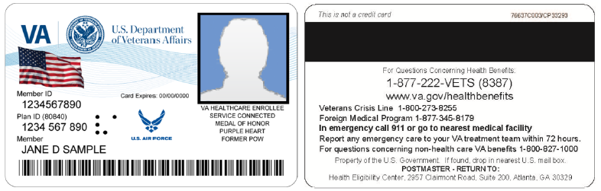

Figure ‑: Example of what the VHIC looks like

## Accessing the VHIC Application

VHIC is a web-based application that users will access via a web browser. The recommended browser is Internet Explorer (currently version 11). The VHIC URL is <https://vic.iam.va.gov/VIC/faces/index.jsf> and is **case sensitive** – it must be entered exactly as shown. After successfully logging in to the VHIC application, users should bookmark this site for easy access in the future. Instructions on how to do just that can be found here: <http://windows.microsoft.com/en-us/internet-explorer/add-view-organize-favorites#ie=ie-11-win-7>.

The best time to bookmark the site is after the user is in the application itself rather than attempting to bookmark the Login screen.

## Browser

Once users are logged into their VA desktop, they will access VHIC using Internet Explorer (IE) by either entering the URL listed above or via the bookmark saved during an earlier session. Please do **NOT** use the *Refresh* button at the top of your browser window if you mistype the VHIC URL. The *Refresh* button will redirect you to the VA website. Please re-enter the VHIC URL and try again.

### Browser Incompatibility Issue

In some instances, users may experience image misplacement or misalignment. This is most likely due to the current browser compatibility settings. You will want to ensure that the browser is not set to Compatibility View.

Examples of Image Misplacement and Other Misalignments:

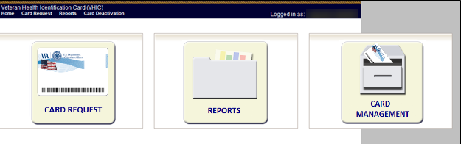

Figure ‑: Over-sized icon buttons on the Home Screen

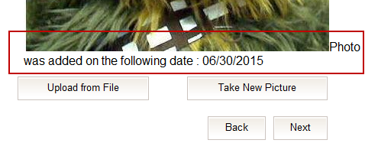

Figure ‑: Words wrapping around the displayed photo on Step 3

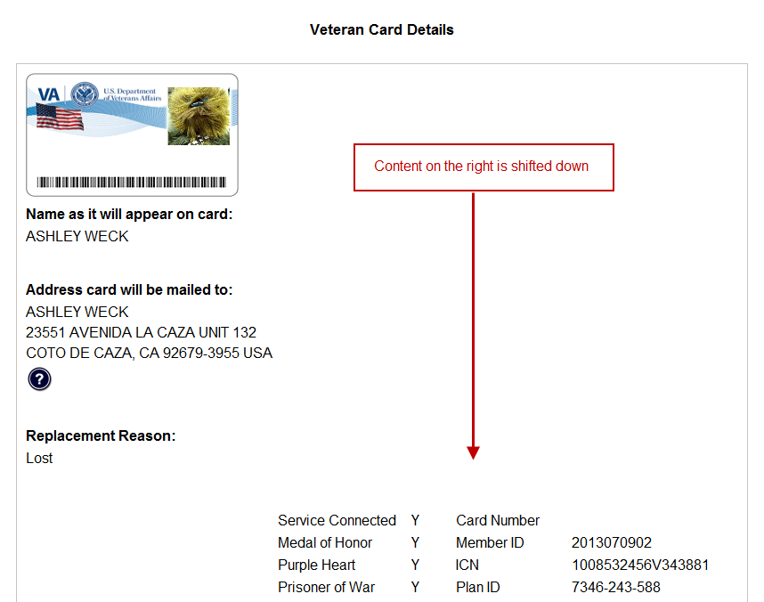

Figure ‑: Content on the right of the Step 6 screen is shifted down

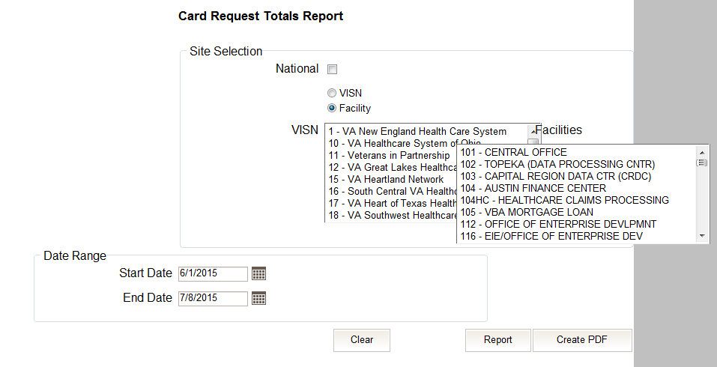

Figure ‑: Both the VISN and Facility selection lists are displayed and shifted to the right

If you are experiencing misalignment issues, follow these steps to verify/update your browser compatibility settings:

1. With Internet Explorer open, right click in the blue area at the top of the browser window.
2. Click on Command Bar to display the Command Tool Bar.

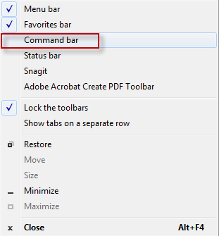

Figure ‑: Internet Explorer's Toolbar Menu

1. Click on the Tools menu button.



Figure ‑: Tools Menu button

1. Click on Compatibility View Settings.

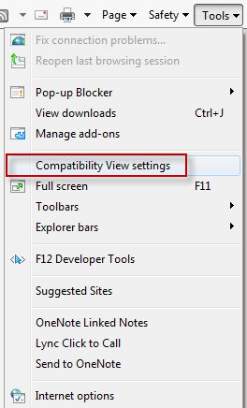

Figure ‑: Tools drop-down menu

1. Uncheck the box next to Display intranet sites in Compatibility View.

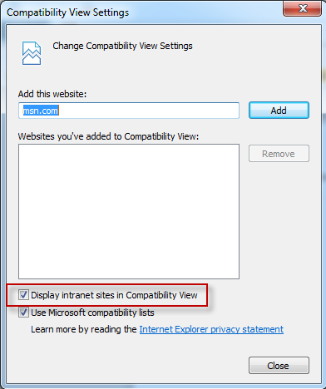

Figure ‑: Compatibility View Settings screen

1. Click the Close button.

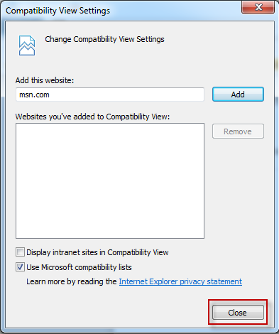

Figure ‑: Compatibility View Settings Screen - Close

*****NOTE:*** *Compatibility mode does need to be turned on in order to access other applications such as Notes in NUMI’s CERMe and the Beneficiary Travel Dashboard. You can turn compatibility mode back on by following the above directions and checking the Display intranet sites in Compatibility View checkbox*.

## Proper Navigation of the VHIC Application

The correct way to navigate through the VHIC application is to use the buttons that are located at the bottom of each screen instead of using the Browser’s built in Back button. Please do **NOT** use the *Back* button at the top of your browser window to navigate back to a previous screen; this will cause errors to occur.

The VHIC user can also navigate to the different features within the VHIC application by clicking on one of the navigation links located in the header near the top left of the screen. The user’s assigned role will determine which links are available as seen below. To see the full home screens for each user role, refer to the 3.2 System Menu section.



Figure ‑: VHIC Administrator and VHIC Technical Administrator (Tier 3) menu



Figure ‑: VHIC Associate and VHIC Supervisor menu



Figure ‑: VHIC Auditor and VHIC Read-Only User menu

## Roles within VHIC

The VHIC application is built to accommodate a specific set of pre-established user roles. During the provisioning process, the VHIC user will have a role assigned to them, which will determine what aspects of the VHIC application are available to them. The following breaks down the specific roles and the areas of access that accompany each role.

If, while utilizing the VHIC application, a user finds they do not have access to items they feel they should have access to or find that they have access to items they should not, based on the definitions listed below, the VHIC user should report this information to their VHIC Supervisor. The VHIC Supervisor should then verify that the proper role has been assigned.

### VHIC Associate

The VHIC Associate role shall be assigned to individuals responsible for processing a card request and resolving card request issues. Associates have the ability to create a card request and have access to a limited number of reports.

### VHIC Supervisor

The VHIC Supervisor shall automatically inherit all access and privileges given to the VHIC Associate. The VHIC Supervisor role is allowed to submit a request for user access to the VHIC application. VHIC Supervisors have the ability to create a card request and have access to most available reports (excluding national versions).

### VHIC Administrator

The VHIC Administrator role is reserved for the VHIC Business (HEC) team members responsible for the creation and maintenance of all other VHIC accounts/roles. The VHIC Administrator shall automatically inherit privileges given to the VHIC Supervisor. Administrators have the ability to create a card request, manage cards, and have access to all available reports.

### VHIC Technical Administrator (Tier 3)

The VHIC Technical Administrator (Tier 3) automatically inherits all access and privileges given to the VHIC Administrator. Technical Administrators (Tier 3) have the ability to create a card request and have access to all available reports as well as access to the Administration page.

### VHIC Auditor

The VHIC Auditor role shall be assigned to users with read-only access to the VHIC System. The VHIC Auditor does not have the ability to create a card request, but does have access to all available reports.

### VHIC Read-Only User

The VHIC Read-Only User role shall be assigned to users with read-only access to the VHIC System. The VHIC Read-Only user does not have the ability to create a card request, but does have access to a limited number of reports.

# Getting Started

## Single Sign-On Internal (SSOi)

Once users are logged into their VA desktop, they will access VHIC using Internet Explorer (IE) by either entering the URL listed above or via the bookmark saved during an earlier session.

Users will be presented with the Single Sign On – internal (SSOi) login screen (*shown below*).

Here the VHIC user will need to use their PIV card to log into the VHIC application.

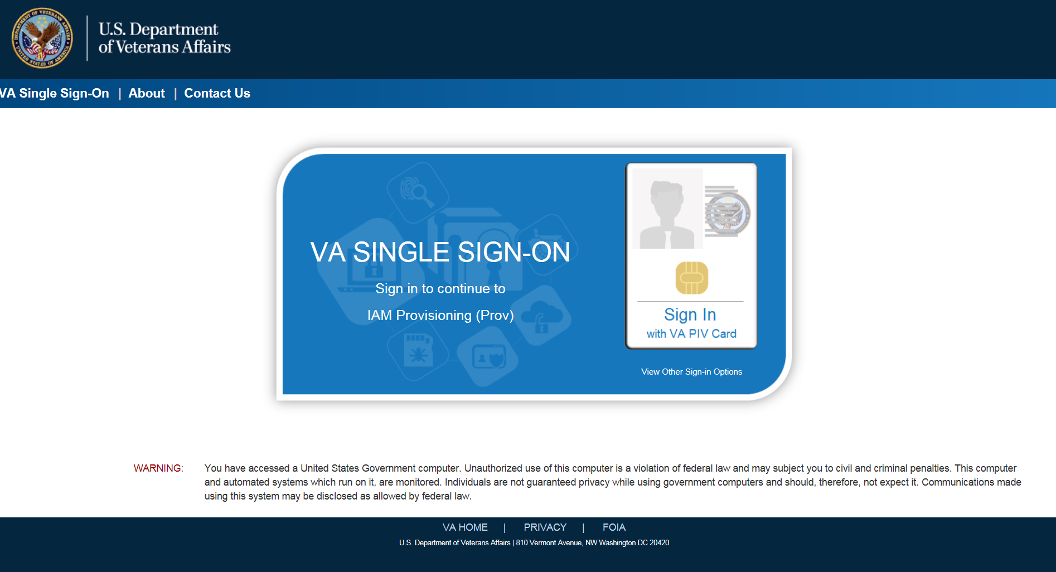

Figure ‑: SSOi Login Screen

## Logging On

The VHIC application is built to accommodate a specific set of pre-established user roles. During the provisioning process, the VHIC user will have a role assigned to them, which will determine what aspects of the VHIC application are available to them. The roles are listed below. For more information on the areas of access that accompanies each role, please refer to section 2.4.

* VHIC Associate
* VHIC Supervisor
* VHIC Administrator
* VHIC Technical Administrator (Tier 3)
* VHIC Auditor
* VHIC Read-Only User

## System Menu

Depending on the VHIC users’ role, they will be presented different Home screens upon logging into the VHIC application.

### VHIC Administrator and Technical Administrator Tier 3

The VHIC Administrator and VHIC Technical Administrator Tier 3 users will be presented with three menu options: Card Request, Reports and Card Management. They can navigate to each of these application modules by either clicking on one of the links located in the header at the top left of the screen or by clicking on one of the icon buttons in the middle of the screen.

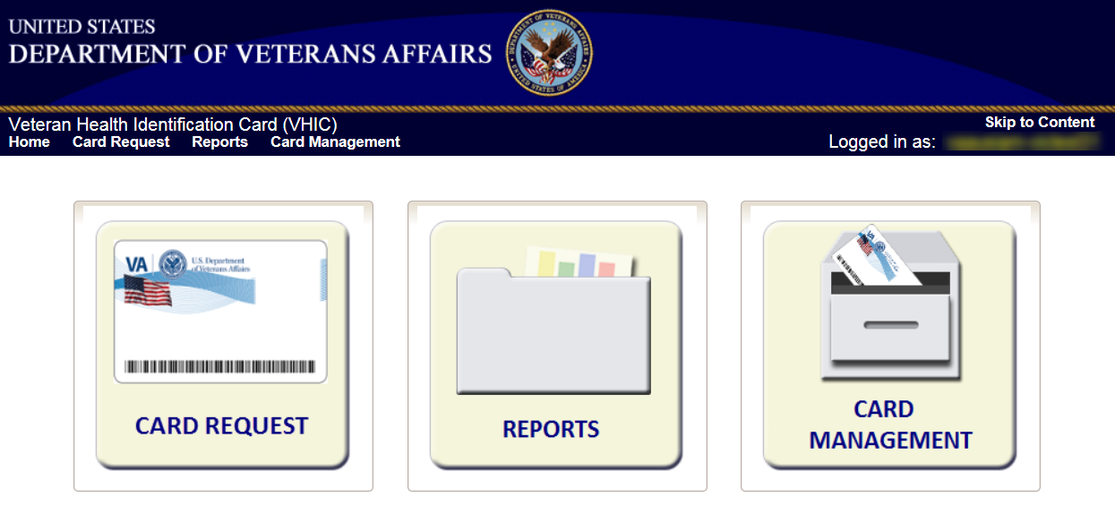

Figure ‑: VHIC Administrator and VHIC Technical Administrator (Tier 3) Home screen

### VHIC Associate and Supervisor

The VHIC Associate and VHIC Supervisor users will be presented with two menu options: Card Request and Reports. They can navigate to each of these application modules by either clicking on one of the links located in the header at the top left of the screen or by clicking on one of the icon buttons in the middle of the screen.

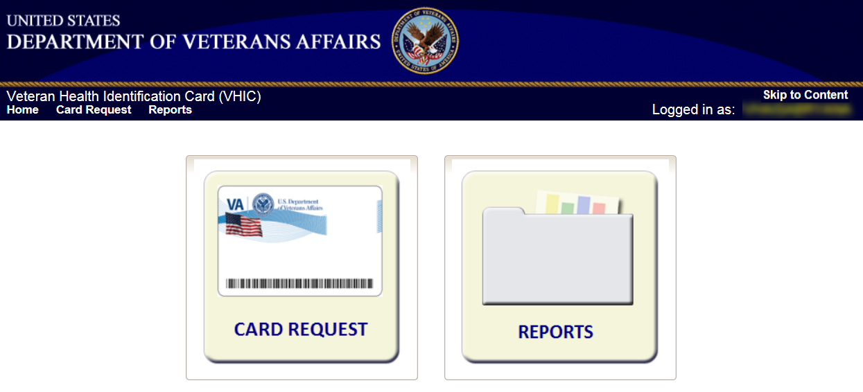

Figure ‑: VHIC Associate and VHIC Supervisor Home screen

### VHIC Auditor and Read-Only User

The VHIC Auditor and VHIC Read-Only users will be presented with the Reports menu option. They can navigate to Reports by clicking on the icon button in the middle of the screen.

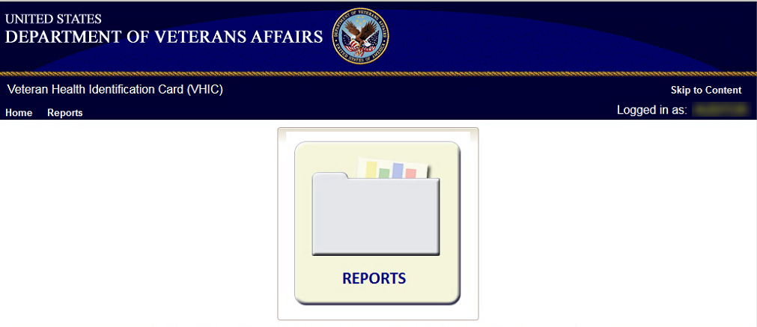

Figure ‑: VHIC Auditor and VHIC Read-Only User Home screen

## Changing User ID and Password

If you have any questions or need help with your User ID or your Password; Contact the Enterprise Service Desk at (855) 673-4357, option 1 (Account or Password Reset), then option 1.

# Proofing Veteran before Requesting a VHIC Card

## Accessing the Identity Management Toolkit

### Accessing the Identity Management Toolkit Directly

The VHIC user will need to go to the Identity Management Toolkit application to look up the Veteran and verify their proofing level and if needed complete the proofing process. The Identity Management Toolkit can be accessed by using the URL in the next section entitled “SSOi.”

#### SSOi

SSOi: <https://mvitkssoi-prod.aac.va.gov/imdquiWeb/login.do>



Figure ‑: Identity Management Toolkit SSOi Logon Screen

The URLs are **case sensitive** – they must be entered exactly as shown. After successfully logging into the Identity Management Toolkit application, users should bookmark this site for easy access in the future. Instructions on how to do just that can be found here: <http://windows.microsoft.com/en-us/internet-explorer/add-view-organize-favorites#ie=ie-11-win-7>.

The best time to bookmark the site is after the user is in the application itself rather than attempting to bookmark the Login screen.

### Accessing Identity Management Toolkit from within the VHIC Application

#### Step 1 of the VHIC Application

When the VHIC user starts the Card Request process, they will see a message on Step 1: Enter Search Terms. “IMPORTANT: Have you Identity Proofed the Veteran in Identity Management Toolkit? (Click here to open [Identity Management Toolkit](https://mvitkssoi-prod.aac.va.gov/imdquiWeb/login.do) in another window)”

The VHIC user can click on the blue words “[Identity Management Toolkit](https://mvitkssoi-prod.aac.va.gov/imdquiWeb/login.do)” which is a hyperlink that will take the user to the Identity Management Toolkit application.

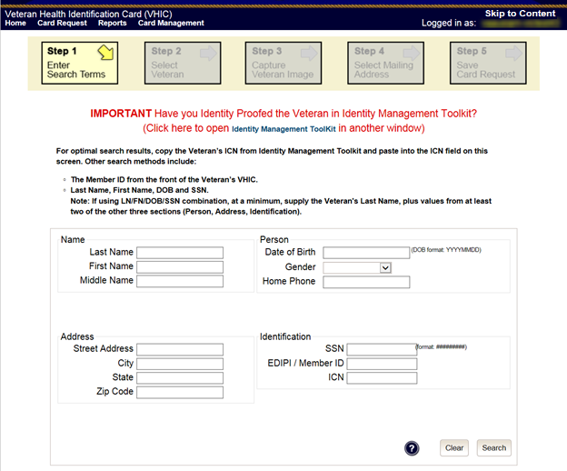

Figure ‑: Step 1: Enter Search Terms with Identity Management Toolkit hyperlink

#### Step 5 of the VHIC Application

The VHIC user will also see a message at the bottom of the Step 5: Save Card Request AFTER a card request has been saved on hold due to *Veteran Not Proofed*.

“**IMPORTANT:** This Veteran still needs to have their Identity Proofing completed.

Follow the steps below:

1. Copy the Veteran’s ICN above and click here to open the [Identity Management Toolkit](https://mvitkssoi-prod.aac.va.gov/imdquiWeb/login.do) in another window.
2. Complete Proofing for the Veteran in Identity Management Toolkit.
3. Enter the Veteran’s ICN on Step 1 of the VHIC Card Request Process.
4. Complete card request process and submit.”

The VHIC user can click on the blue words “[Identity Management Toolkit](https://mvitkssoi-prod.aac.va.gov/imdquiWeb/login.do)” which is a hyperlink that will take the user to the Identity Management Toolkit application.

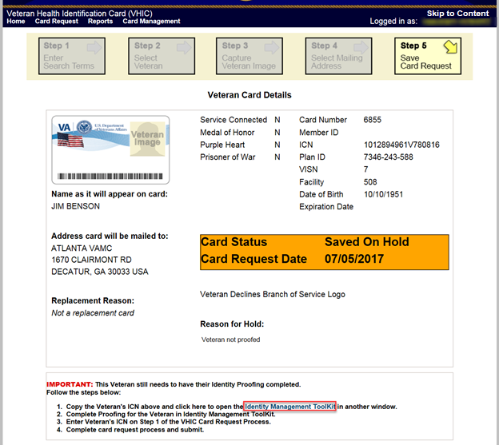

Figure ‑: Step 5 - Save Card Request with Identity Management Toolkit hyperlink

### Logging out of Identity Management Toolkit

**To Log Off:**

1. Click **Log off** in the menu bar. You can log off from most of the pages except the logon screen. Logoff is also available from the Navigation Bars.



Figure ‑: Log Off link located in the menu bar

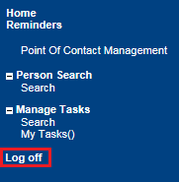

Figure ‑: Log Off link located in the Navigation pane

1. IdM TK has a built-in idle feature. After 60 minutes of inactivity, the idle warning message is displayed as seen in *Figure 4‑6: Identity Management Toolkit Idle message*. Enter your password and click **Submit**. After you log back on, you are returned to the screen you were previously working on.

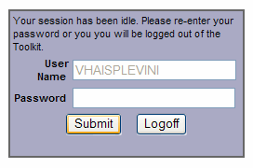

Figure ‑: Identity Management Toolkit Idle message

## Proofing Process and Steps

This section will give the VHIC user the step-by-step details of the proofing process in the Identity Management Toolkit.

### Looking up the Veteran

When you first log into the **Identity Management Toolkit** application, you will be able to search for the Veteran by either entering the *Veteran’s ICN* or their *Identity traits* in the **Quick Search** section. You can also click on the **[Search]** link on the left side of the screen to be taken to the full identity traits search page to enter more traits as needed.

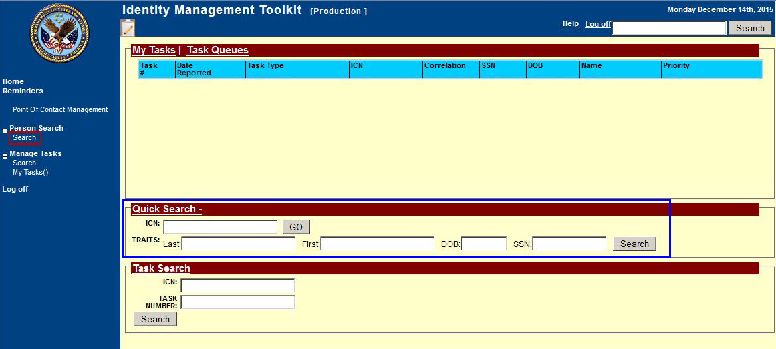

Figure ‑: Identity Management Toolkit Search Screen

#### Quick Search

##### Quick Search with Identity Traits

Enter the Identity Traits for the Veteran that you want to start an Identity Proofing for. Once you have entered the traits and click the **[Search MVI]** button.

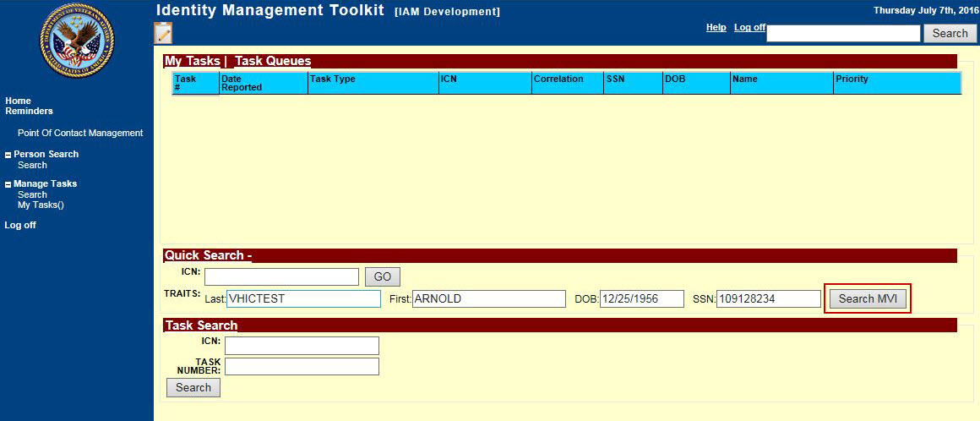

Figure ‑: Identity Management Toolkit Quick Search with Traits

MVI will display the search results under the Identity Traits fields. Click on the **ICN** of the Veteran that matches the one you want to work on. This will take you the *Primary View* screen for the selected Veteran as shown in the section entitled Primary View.

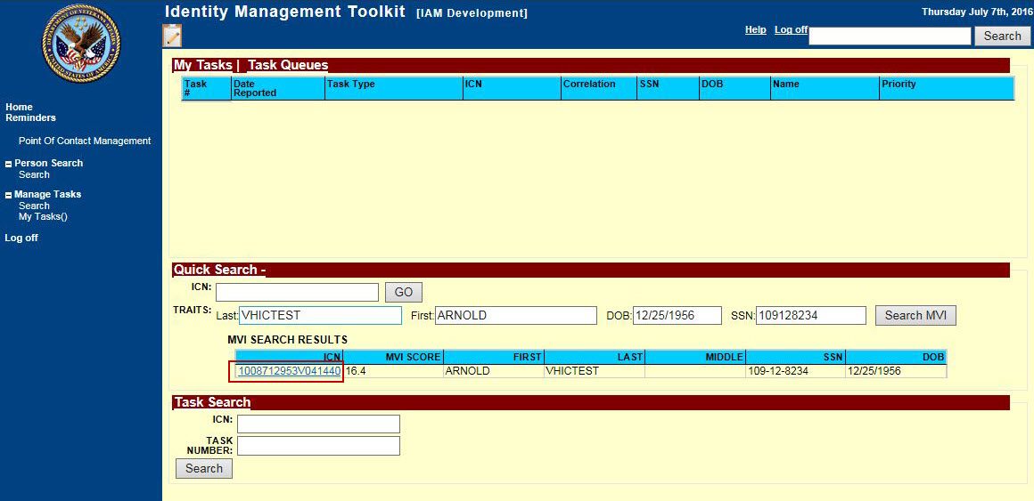

Figure ‑: Identity Management Toolkit Quick Search - MVI Search Results

##### Quick Search with ICN

Enter the *Veteran’s ICN* in the *ICN* field then click the **[GO]** button. This will take you the *Primary View* screen for the selected Veteran as shown in the section entitled Primary View.

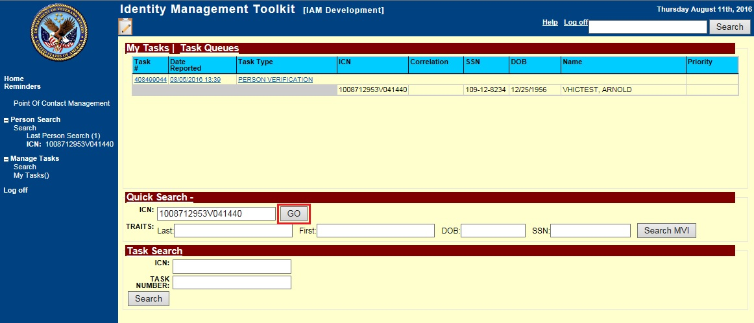

Figure ‑: Identity Management Toolkit Quick Search with ICN

#### Person Search

When you are on the *Home* screen of the Identity Management Toolkit and you want to be able to enter more identity traits to search for the Veteran, click on the **Search** link on the left side of the screen.

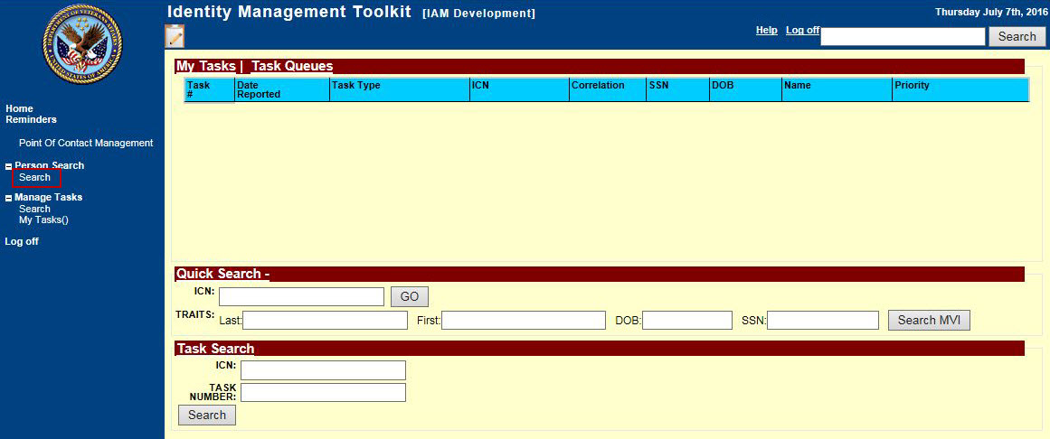

Figure ‑: Identity Management Toolkit Search Screen; Click Search

This will take you to the *Search For Person* screen. On this screen you can either enter only the *Veteran’s ICN* and click the **[Search]** button, or enter as many of the *Veteran’s Identity Traits* that you need in order to find the Veteran record that you are looking for and click the **[Search]** button.

If you are using a criteria-based search, the Last name plus two other fields (not including Middle Name) are required.

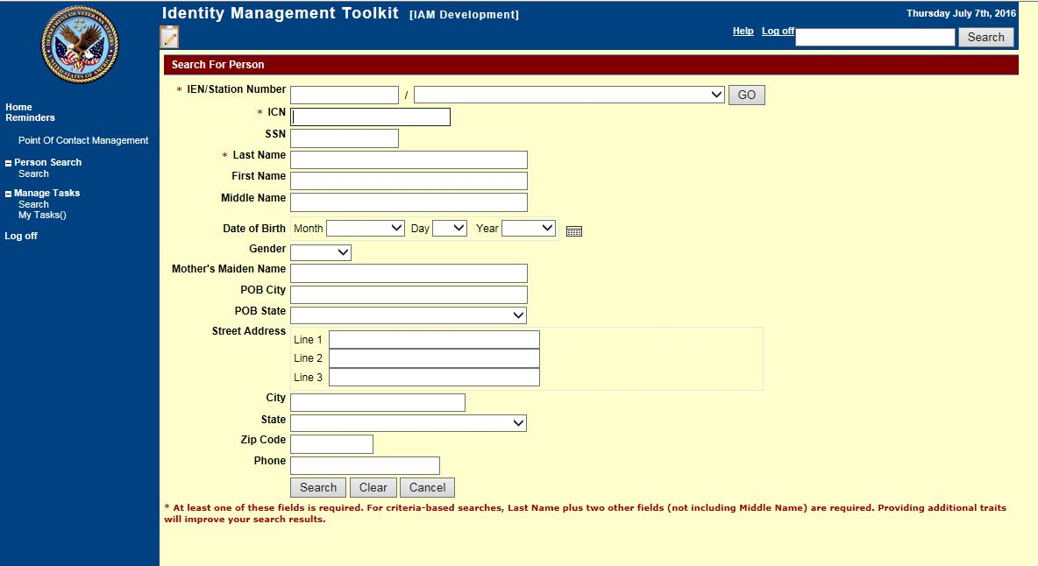

Figure ‑: Identity Management Toolkit Search For Person screen

Once you have entered the search criteria for the Veteran you are looking for, click the **[Search]** button. This will take you the *Primary View* screen for the selected Veteran as shown below in section the section entitled Primary View.

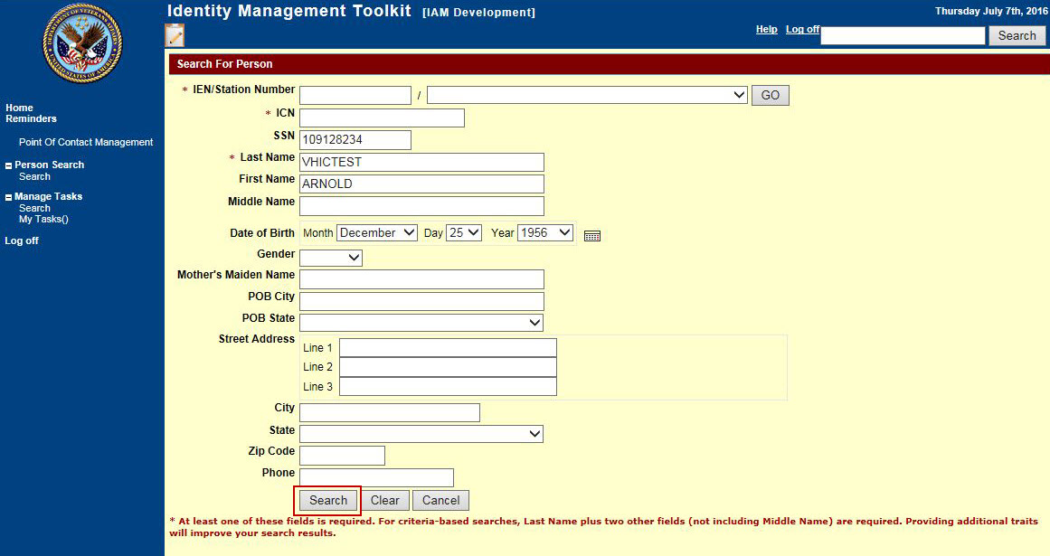

Figure ‑: Identity Management Toolkit Search For Person screen; Click Search

### Primary View

Once you have looked up the Veteran that you are searching for, you will be taken to the **Primary View Data** screen. Verify that the traits displayed in the *Primary View Data* section is correct and take note of the *Level of Assurance*.

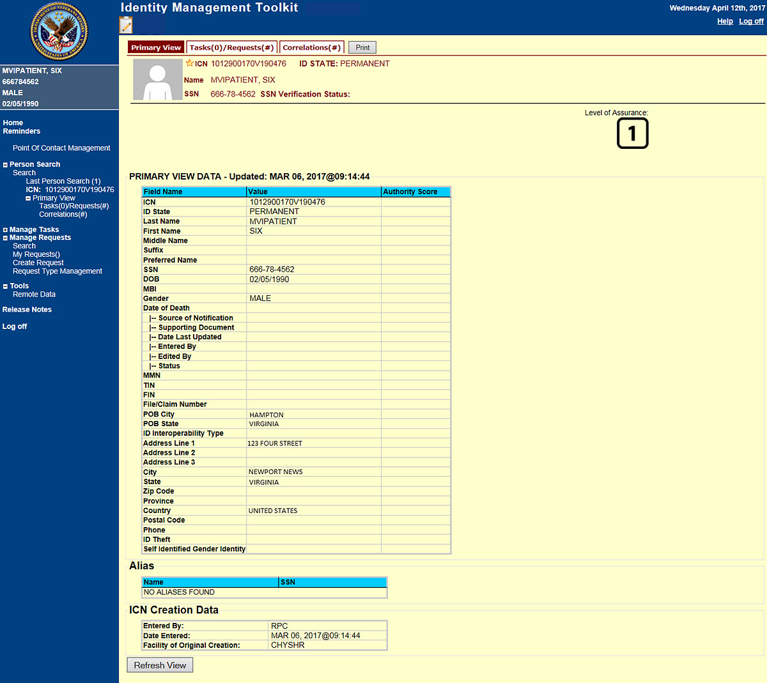

Figure ‑: Identity Management Toolkit Primary View Screen

### If Level of Assurance is Level 1 – Complete Proofing

If the traits in the *Primary View* are correct and the *Level of Assurance* is displayed as **Level 1**, click on the  or on the **Tasks/Requests** tab at the top of the screen to complete the proofing process.

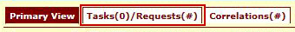

Figure ‑: Tasks/Requests tab highlighted

Once you are on the Tasks/Requests screen, click on the **[New Proofing Task]** button.

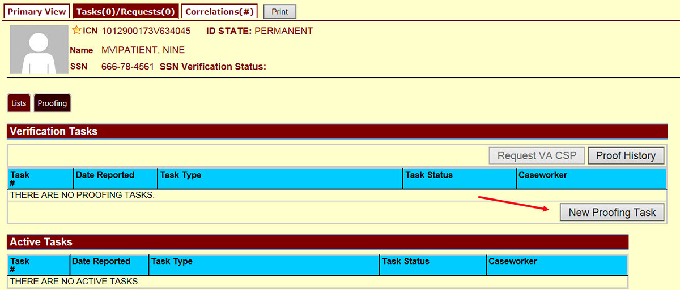

Figure ‑: Tasks/Requests screen; click New Proofing Task

You will see a pop up reminder to confirm receipt of valid Identification.

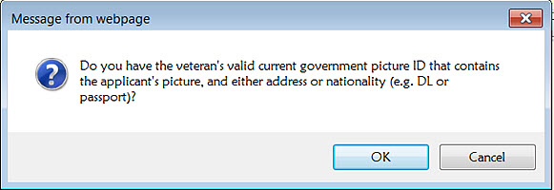

Figure ‑: Identification Confirmation Message

This takes you to the Task Details screen. Now click on the **Person Verification** tab.

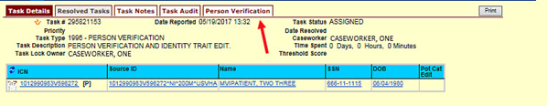

Figure ‑: Task Details screen; Click Person Verification

When you get to the Person Verification screen, you will see the Veteran’s information from the Primary View screen populated and the fields on the left side of the form will be marked green.



***NOTE:*** *If any changes need to be made to the Veteran’s Identity Information other than Address, those changes will need to be updated before the proofing process can be completed.*

*If you change the address on this screen, the new address that you enter will only be used for this single proofing event. It will* ***NOT*** *be updated in any other VA system and will not be available to select as a mailing address in the VHIC application.*

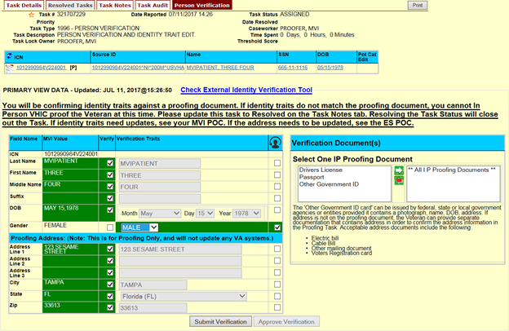

Figure ‑: Identity Management Toolkit Person Verification screen

Next you will need to enter the information for the type of documents that were submitted for proof of identity.

Select the document from one of the lists on the right side of the form and click on the white arrow to move the selected document type to the box on the right.

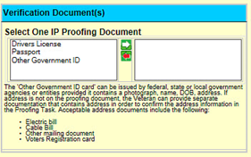

Figure ‑: Verification Document Section; Select document type

If you select one of the documents from the top list, you will be asked to enter the details of that document in the fields that will appear under the document list box.

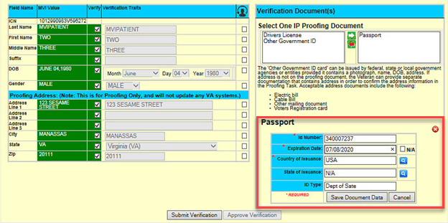

Figure ‑: Verification Document Section; Enter document details

Enter the required information about the document selected and click the **[Save Document Data]** button.

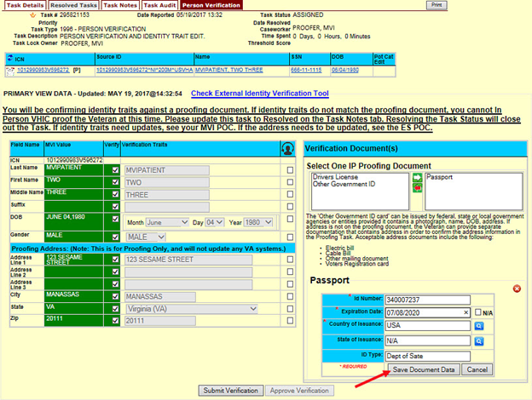

Figure ‑: Verification Document Section; Click Save Document Data

Once you have entered all of the information for the documents that were provided and verified the Veteran’s identity, click on the **[Submit Verification]** button to complete the proofing task.

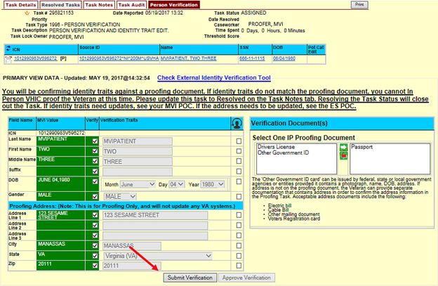

Figure ‑: Identity Management Toolkit Person Verification screen; Click Submit Verification

After you click the submit button, you will see a spinning wheel appear in the middle of the screen to let you know that the proofing verification is being processed.

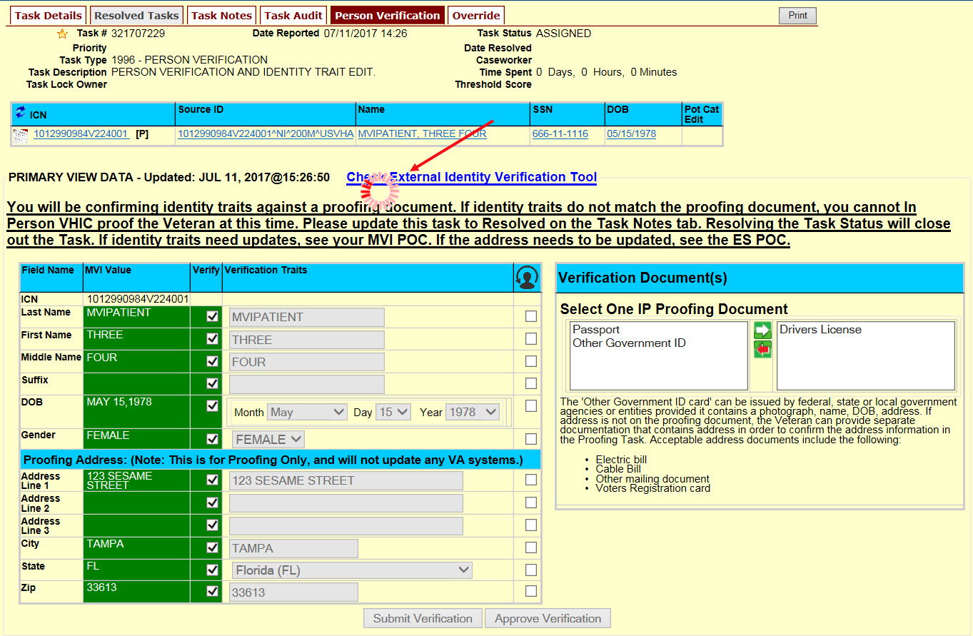

Figure ‑: Proofing verification in progress

Once the proofing task has been completed, you will receive a pop up message.

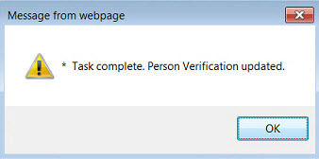

Figure ‑: Task Complete Pop Up Message

After clicking the OK button, you will be returned to the Primary View screen where you will see a message at the top of the screen saying “Task complete and resolved.”

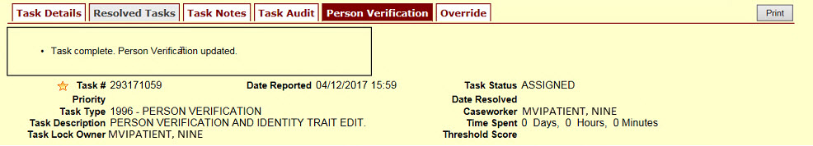

Figure ‑: Person Verification Updated Message

You should also see that the *Level of Assurance* is now shown as **Level 2**.

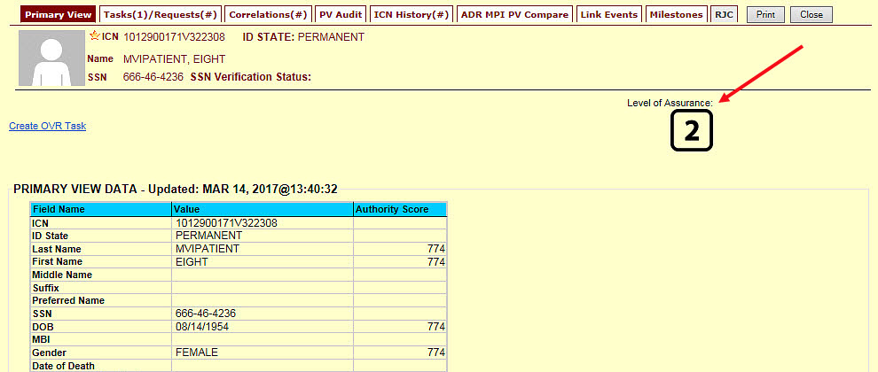

Figure ‑: Identity Management Toolkit Primary View screen - Proofing Complete

If for some reason the *Level of Assurance* is still showing as **Level 1**, then scroll to the bottom of the Primary View screen and click on the **[Refresh View]** button. The *Level of Assurance* should then be updated to **Level 2**.

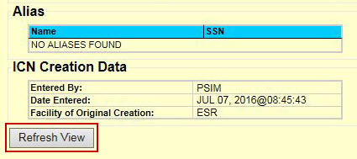

Figure ‑: Refresh View button

Once the proofing task has been completed and the *Level of Assurance* has been updated **to Level 2**, highlight the *Veteran’s ICN* at the top of the screen and copy it, either by clicking **[Ctrl + C]** or right clicking on the highlighted number and selecting copy from the menu that displays.

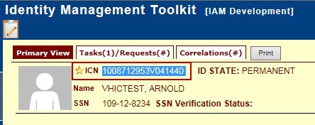

Figure ‑: The Veteran's ICN is highlighted

Now you will log into the VHIC application and start the card request. On **Step 1: Enter Search Terms** of the Card Request process; you will paste the *Veteran’s ICN* that you copied, from the Primary View screen in the Identity Management Toolkit application, into the *ICN* field in the lower right side of the screen.

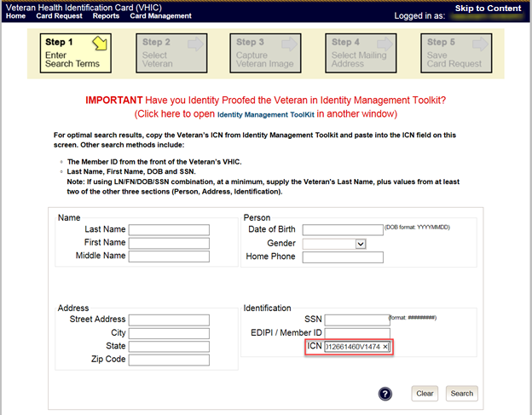

Figure ‑: Step 1: Enter Search Terms - ICN has been entered

### If Level of Assurance is Level 2 – Continue to Issue VHIC

If the *Level of Assurance* is displayed as **Level 2** on the Primary View screen, copy the *Veteran’s ICN* from the top of the Identity Management Toolkit screen so you can use that to search for the Veteran on **Step 1: Enter Search Terms** of the Card Request process in the **VHIC** application.

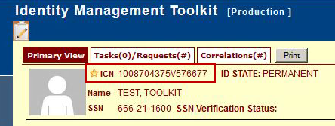

Figure ‑: The Veteran's ICN is highlighted

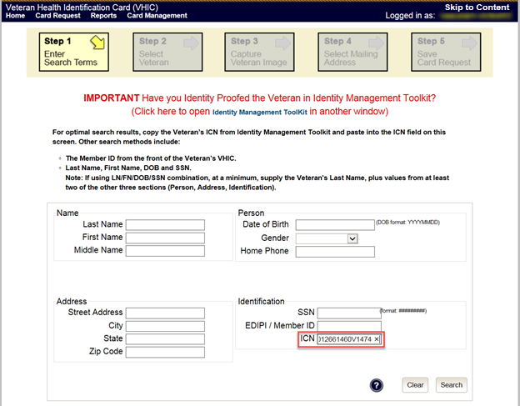

Figure ‑: Step 1: Enter Search Terms - ICN has been entered

# Creating a VHIC Card – The Card Request Process

Table : Who can process a card request?

| At a Glance… |  |
| --- | --- |
| Who can process a card request? | *Administrator, Supervisor, Associate, Tech Admin (Tier 3)* |

This section will walk the VHIC user through the process of creating a card for a Veteran. During the card request process, issues may arise that will require the card to be put on hold. These cases will be covered in section 5.6 On-Hold Reasons Explained.

The card issuance process follows numbered steps shown next.

1. Enter Search Terms
2. Select Veteran
3. Capture Veteran Image
4. Select Mailing Address
5. Save Card Request

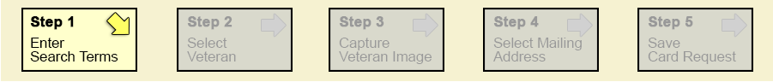

Figure ‑: Card Request Navigation Bar

***NOTE*** *The appearance of the step block will change to indicate the step you are currently working by appearing to be the brightest. See the illustration below.*

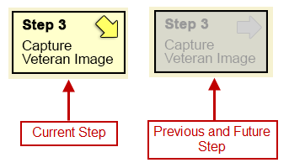

Figure ‑: Navigation Bar Step appearance by state

These steps are fully explained below. We will now walk through each of the steps required to complete a VHIC card request for New VHICs and Replacement VHICs. We will also go over the steps for placing a card request on hold as well as taking a card request off hold.

## New VHIC: Veteran Level 2 Proofed through Identity Management Toolkit

### Step 1: Enter Search Terms

The first step in the process is to find the Veteran in the system. This is accomplished by entering enough search criteria to trigger a match within Master Veteran Index (MVI). The top of the screen offers guidance regarding the set of traits recommended to ensure a best match is found. These are guidelines and not necessarily the required set of traits that must be entered.

However, for optimal search results, copy the Veteran’s ICN from the Identity Management Toolkit and paste it into the ICN field on this screen.

Other search methods include:

* The Member ID from the front of the Veteran’s VHIC.
* Last Name, First Name, DOB and SSN.

***NOTE:*** *If using LN/FN/DOB/SSN combination, at a minimum, supply the Veteran's Last Name, plus values from at least two of the other three sections (Person, Address, and Identification).*

The more traits entered, the more likely a match will be returned.

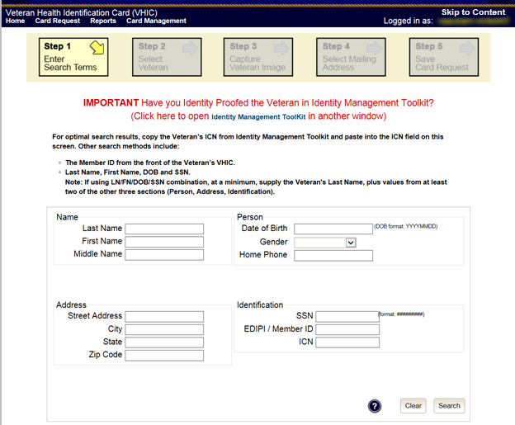

Figure ‑: Enter Search Terms screen

Additional guidance is also available on-screen by clicking on the blue circle containing a question mark.



Figure ‑: Help icon

This type of help is available throughout the application and will provide additional detail or clarification for that particular step or section.

Once the information has been entered into the required fields, click on **[Search]** to proceed to the next step.

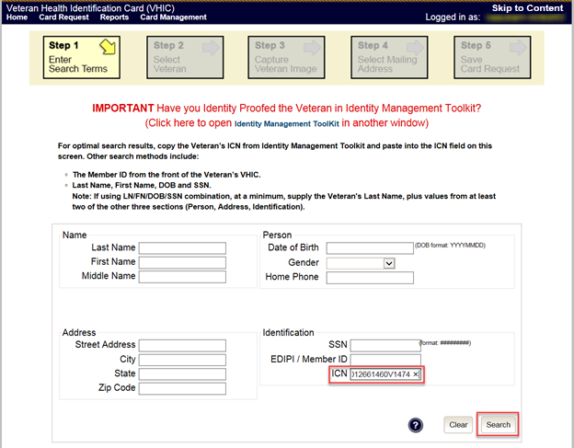

Figure ‑: Enter Search Terms screen

### Step 2: Select Veteran

Once the search has completed, the results of that search will be displayed on screen. From the list provided (up to 10 matches may be returned), select the appropriate Veteran by clicking on the Veteran’s name which is hyperlinked.

If the correct Veteran is not in the list, click the **[Back]** button and verify the traits entered are correct. If the traits are correct, try adding additional information to aid in triggering a match.

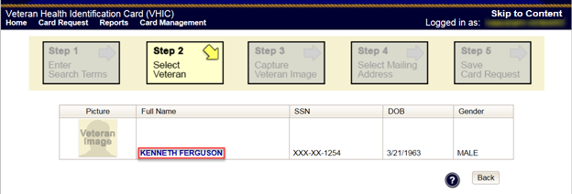

Figure ‑: Select Veteran screen

### Step 3: Capture Veteran Image

Once a selection has been made, the next step in the process is to capture the Veteran image. VHIC provides several ways to handle this operation: Take New Picture, Upload from file, or Reuse Existing Image.

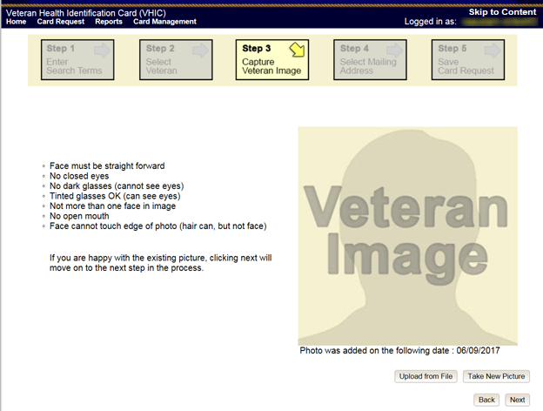

Figure ‑: Capture Veteran Image screen

#### Take New Picture

Upon arriving to the Capture Veteran Image page, if there is no useable image for the Veteran already on file, a “No Photo” image will appear in the image capture area. Click **[Take New Picture]** to capture the Veteran’s image. The camera should become active and the Veteran should be visible in the image capture window. (If the Veteran and background is not visible, refer to section 8.4.3. Adobe Flash Permissions of the VHIC User Guide - Volume 4 - Troubleshooting to ensure your camera settings are correct.)

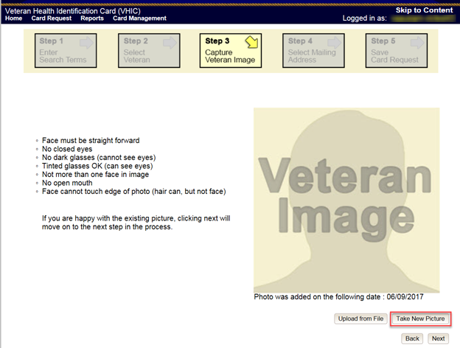

Figure ‑: Capture Veteran Image screen – Take New Picture

Using the provided silhouette, ensure that that the Veteran is lined up properly. Prior to clicking **[Capture Image]** ensure the additional image capture guidelines provided on screen are met:

* Face must be straight forward
* No closed eyes
* No dark glasses (cannot see eyes)
* Tinted glasses OK (can see eyes)
* Not more than one face in image
* No open mouth
* Face cannot touch edge of photo (hair can, but not face)

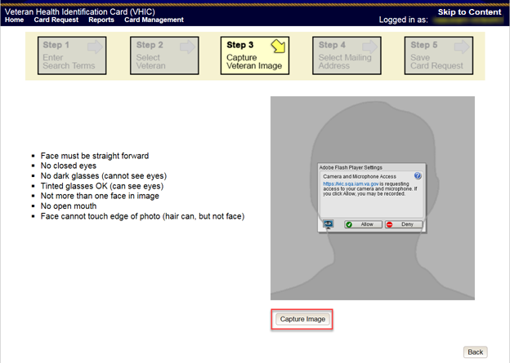

Figure ‑: Capture Veteran Image screen – Capture Image

Once the image is captured, take a moment to review that the image meets all desired guidelines before proceeding. If the image is acceptable, click **[Next]** to continue on to the next step.

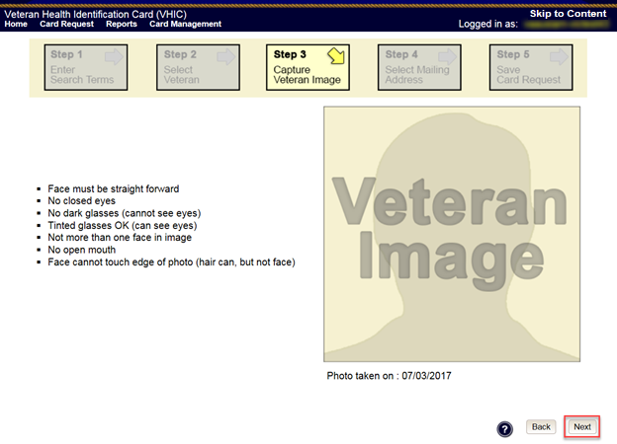

Figure ‑: Capture Veteran Image screen – Accept new photo; click Next

***NOTE:*** *If the image does not meet the guidelines or the Veteran would prefer a new photo be taken or uploaded, this can be done at this point as well by clicking the* ***[Back]*** *button to take a new picture or upload a photo.*

#### Upload from File

In some cases, it may be necessary to upload an image for a Veteran (i.e., they are unable to be present during the card request process due to health issues, etc.) In these cases, VHIC offers the option to upload a photo by selecting the **[Upload from File]** option.

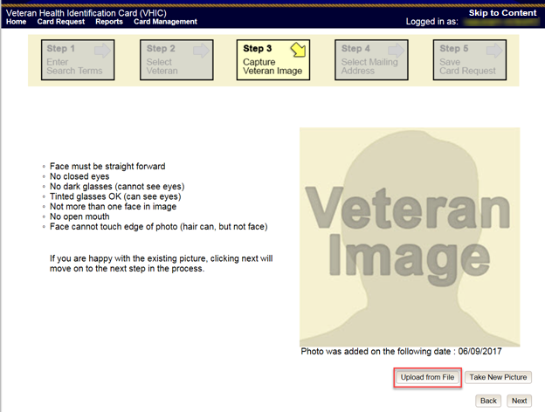

Figure ‑: Capture Veteran Image screen – Upload from File

Once this option is selected, a **[Browse…]** button will appear next to a text field. Clicking this button will open up another window to allow for the desired image to be located and selected. The accepted file formats are JPG, GIF, PNG, and BMP. For best results use a 400x400 pixel JPG image. It should also be noted that any adjustments that need to be made to the image to meet the specified guidelines, such as crop and resize, this should be done before the image is uploaded.

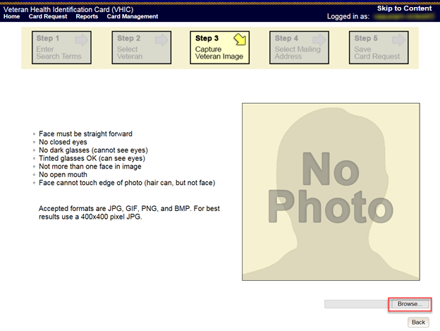

Figure ‑: Capture Veteran Image screen – Upload photo; click Browse

Once the file has been selected, an **[Upload]** button will become available. Clicking this will import the image and it will now be visible in the image capture area.

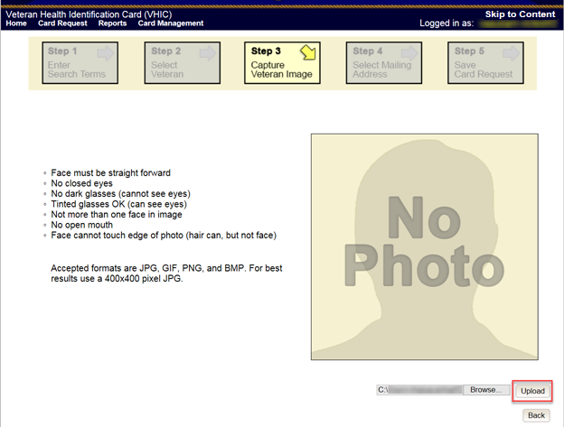

Figure ‑: Capture Veteran Image screen – Upload photo; click Upload

The user can move the slider below the image window to zoom the image in or out to match the silhouette, the image can also be dragged to line the Veteran’s face inside the silhouette as well.

Once again, be sure to review the image to ensure it meets the specified guidelines before clicking the **[Next]** button to continue.

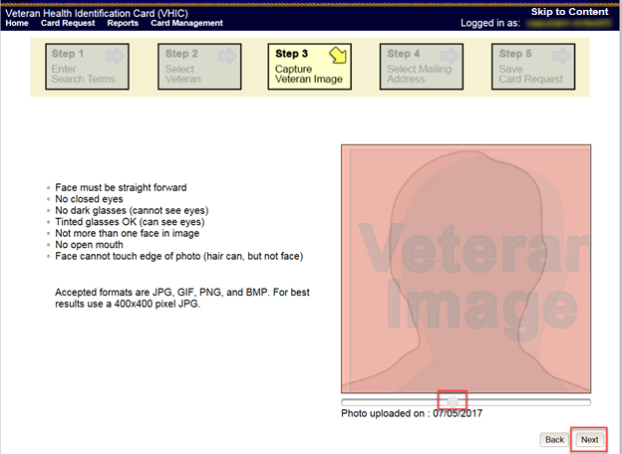

Figure ‑: Capture Veteran Image screen – Edit photo; click Next

#### Reuse Existing Image

In the event the Veteran has an existing photo in the system that is less than ten years old, this will appear in the image capture area upon entry to Step 3. If this image meets the required guidelines, it may be reused for the current card request process. Simply click **[Next]** to continue on to Step 4.

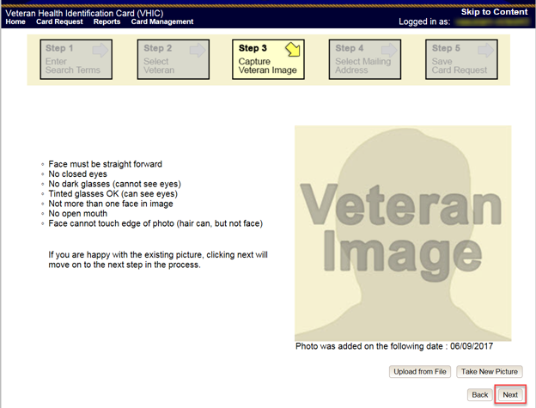

Figure ‑: Capture Veteran Image screen – Reuse Existing Photo; click Next

The VHIC application will ask the user to confirm that they want to reuse the existing photo for this Veteran. Click the **[OK]** button to continue to Step 4: Verify Identity Attributes.

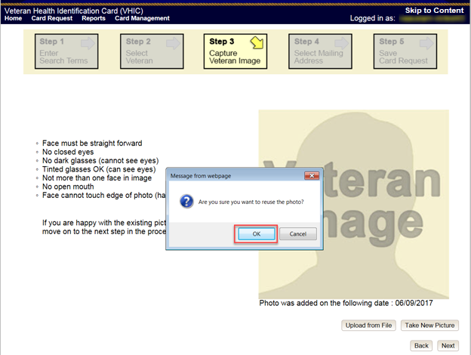

Figure ‑: Capture Veteran Image screen – Reuse Existing Photo; click OK

***NOTE:*** *If the image does not meet the guidelines or the Veteran would prefer a new photo be taken or uploaded, this can be done at this point as well by selecting either* ***[Upload from File]*** *or* ***[Take New Picture]****.*

### Step 4: Select Mailing Address

This screen displays the information retrieved from the Master Veteran Index (MVI) and the Enrollment System (ES) for the selected Veteran. The purpose of this screen is to verify the displayed information, and to determine where the Veteran’s card should be mailed.

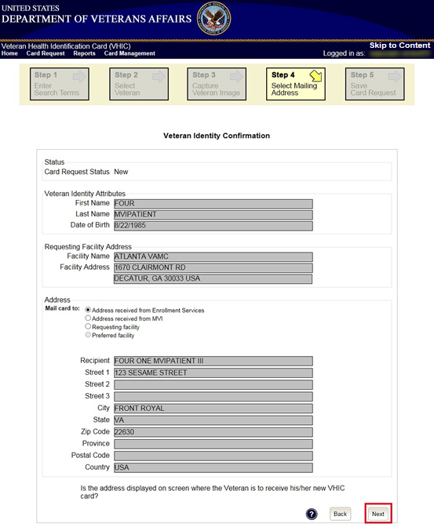

Figure ‑: Select Mailing Address screen

This step provides several mailing options for the card:

* Mail to the address received from Enrollment Services
* Mail to the address received from MVI
* Mail to the requesting facility
* Mail to the preferred facility

*****NOTE:*** *If Enrollment has flagged the Veteran’s address as bad, a message stating why, as well as additional guidance on how to proceed, will be displayed near the top of the screen. At this point, if the Veteran opts to* ***not*** *update their information with ES, the Associate MUST choose one of the remaining viable address options for mailing the card in order to proceed with the card request process.*

*****NOTE:*** *If MVI has flagged the Veteran’s address as bad, a message stating why, as well as additional guidance on how to proceed, will be displayed near the top of the screen. At this point, if the Veteran opts* ***not*** *to update their information with MVI or ES, the Associate MUST choose one of the remaining viable address options for mailing the card in order to proceed with the card request process. Selecting a radio button will automatically update the address information based on the selection. The process cannot continue until the appropriate radio button has been selected*.

*****NOTE:*** *If no preferred facility information has been received from ES or the preferred facility address is flagged as bad, a message stating why, as well as additional guidance on how to proceed, will be displayed near the top of the screen. The Associate MUST choose one of the remaining viable address options for mailing the card in order to proceed with the card request process. Selecting a radio button will automatically update the address information based on the selection. The process cannot continue until the appropriate radio button has been selected*.

Selecting a radio button will automatically update the address information based on the selection. The process cannot continue until the appropriate radio button has been selected.

If the address for the Requesting Facility is not correct, then the VHIC user would need to request help with correcting the address by contacting the Enterprise Service Desk at (855) 673-4357, option 3 (Applications), then option 1. Alternately, send an email message to ESD DEV OPS [(ESD@va.gov)](mailto:ESD@va.gov) with correction details.

If the information on the screen is a correct match, select the **[Next]** button in the lower right hand to move forward.

### Status Section

At the top of the Step 4 screen is the Status section. When going through the card request process, one of the following Card Request Status options will be displayed: *New*, *Replacement*, or *On Hold*. Since this is a new card request the status displayed is *New*.

### Step 5: Save Card Request

Step 5 – Save Card Request – gives the VHIC user and the Veteran one more opportunity to review all of the information on the screen for accuracy.

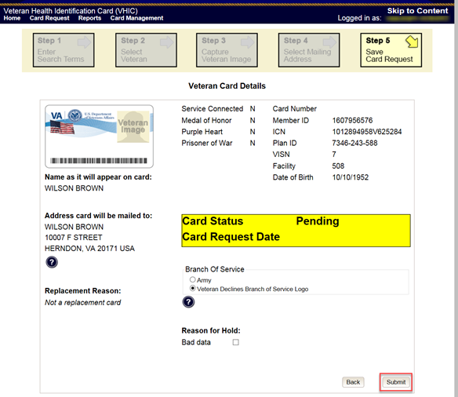

Figure ‑: Save Card Request review screen

This screen contains the following information for review:

* Name as it will appear on card
* Address card will be mailed to (*this also contains the name as it will appear in the mailing address*)
* Replacement reason (*if applicable*)
* Reason for hold (*if applicable*)
* Service connected status
* Medal of Honor status
* Purple Heart status
* Prisoner of War status
* Branch of Service selection
* Date of Birth

Other fields that either will be populated or will populate upon final submission are:

* Card Number (*populates upon final submission*)
* Member ID
* ICN
* Member Benefit Plan ID
* VISN and Facility where request is being processed

#### Branch of Service

If available, the Veteran’s Branch of Service options will be displayed on screen. The Veteran should be given the opportunity to select which logo they would prefer to appear on their card or if they would like to decline the logo option altogether (*default*). The appropriate radio button should be selected based upon the Veteran’s preference. Only those branches of service that are listed in the Enrollment System and in which the Veteran has served will be shown. This will need to be chosen before submitting the card request.

**

***NOTE:*** *Only one Branch of Service logo can appear on the card; those with more than one branch will have to select one, or decline to show any logo.*

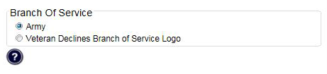

Figure ‑: Branch of Service Selection

#### Save Card Request: New

If the card is a new request, meaning the Veteran has never had a VHIC prior to this request; the Replacement Reason section will state the following: *Not a replacement card*.

Upon submission, a *Card Number* will be generated as well as an *Expiration Date* and *Card Request Date*. The colored field will change from yellow to green and the corresponding Card Status will change from *Pending* to *Submitted*.

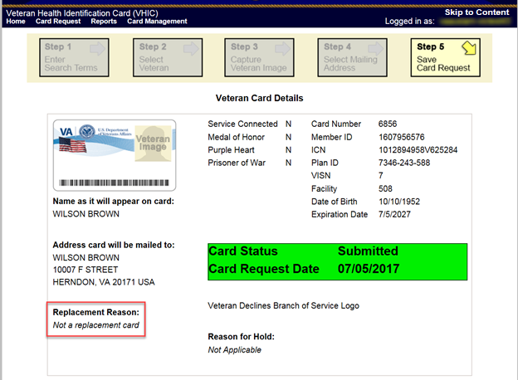

Figure ‑: New Card Request Submitted

## New VHIC: Veteran has NOT been Level 2 Proofed through Identity Management Toolkit

### Step 1: Enter Search Terms

The first step in the process is to find the Veteran in the system. This is accomplished by entering enough search criteria to trigger a match within Master Veteran Index (MVI). The top of the screen offers guidance regarding the set of traits recommended to ensure a best match is found. These are guidelines and not necessarily the required set of traits that must be entered.

However, for optimal search results, copy the Veteran’s ICN from the Identity Management Toolkit and paste it into the ICN field on this screen.

Other search methods include:

* The Member ID from the front of the Veteran’s VHIC.
* Last Name, First Name, DOB and SSN.

***NOTE:*** *If using LN/FN/DOB/SSN combination, at a minimum, supply the Veteran's Last Name, plus values from at least two of the other three sections (Person, Address, and Identification).*

The more traits entered, the more likely a match will be returned. Additional guidance is also available on-screen by clicking on the blue circle containing a question mark.



Figure ‑: Help icon

This type of help is available throughout the application and will provide additional detail or clarification for that particular step or section.

Once the information has been entered into the required fields, click on **[Search]** to proceed to the next step.

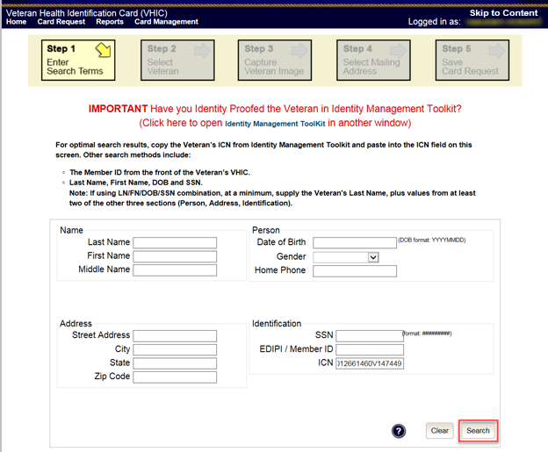

Figure ‑: Enter Search Terms screen

### Step 2: Select Veteran

Once the search has completed, the results of that search will be displayed on screen. From the list provided (up to 10 matches may be returned), select the appropriate Veteran by clicking on the Veteran’s name which is hyperlinked.

If the correct Veteran is not in the list, click the **[Back]** button and verify the traits entered are correct. If the traits are correct, try adding additional information to aid in triggering a match.

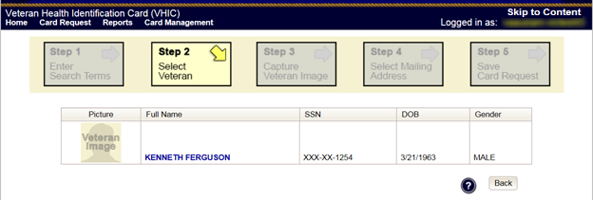

Figure ‑: Select Veteran screen

### Step 3: Capture Veteran Image

Once a selection has been made, the next step in the process is to capture the Veteran image. VHIC provides several ways to handle this operation: Take New Picture, Upload from file, or Reuse Existing Image.

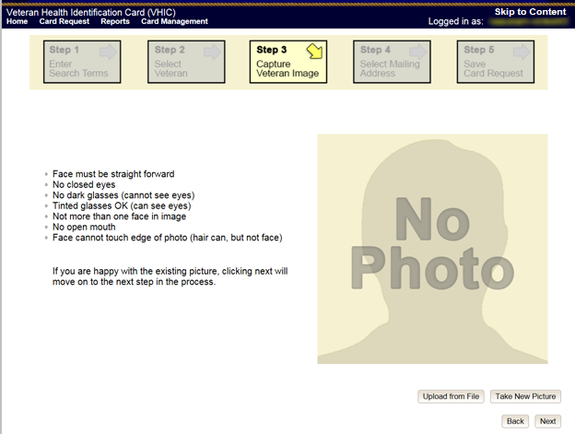

Figure ‑: Step 3 - Capture Veteran Image screen

#### Take New Picture

Upon arriving to the Capture Veteran Image page, if there is no useable image for the Veteran already on file, a “No Photo” image will appear in the image capture area. Click **[Take New Picture]** to capture the Veteran’s image. The camera should become active and the Veteran should be visible in the image capture window. (If the Veteran and background is not visible, refer to Section 8.4.3. Adobe Flash Permissions of the VHIC User Guide - Volume 4 - Troubleshooting to ensure your camera settings are correct.)

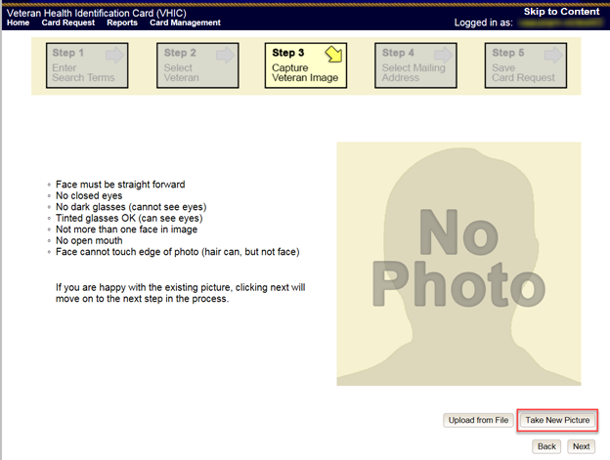

Figure ‑: Capture Veteran Image screen – Take New Picture

Using the provided silhouette, ensure that that the Veteran is lined up properly. Prior to clicking **[Capture Image]** ensure the additional image capture guidelines provided on screen are met:

* Face must be straight forward
* No closed eyes
* No dark glasses (cannot see eyes)
* Tinted glasses OK (can see eyes)
* Not more than one face in image
* No open mouth
* Face cannot touch edge of photo (hair can, but not face)

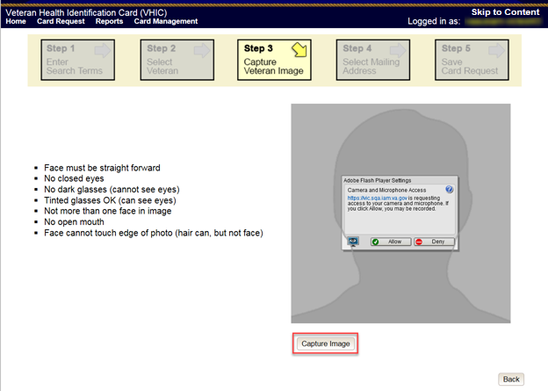

Figure ‑: Capture Veteran Image screen – Capture Image

Once the image is captured, take a moment to review that the image meets all desired guidelines before proceeding. If the image is acceptable, click **[Next]** to continue on to the next step.

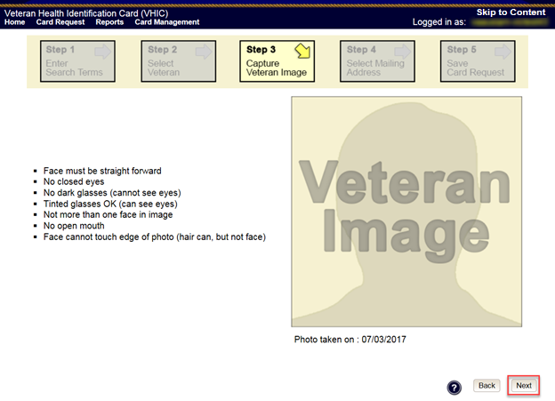

Figure ‑: Capture Veteran Image screen – Accept new photo; click Next

***NOTE:*** *If the image does not meet the guidelines or the Veteran would prefer a new photo be taken or uploaded, this can be done at this point as well by clicking the* ***[Back]*** *button to take a new picture or upload a photo.*

### Step 4: Select Mailing Address

This screen displays the information retrieved from the Master Veteran Index (MVI) and the Enrollment System (ES) for the selected Veteran. The purpose of this screen is to verify the displayed information, and to determine where the Veteran’s card should be mailed.

If the Veteran was not LOA 2 Proofed through the Identity Management Toolkit before the starting the card request process, the VHIC user will see the message:

**“WARNING: Veteran not Identity Proofed”**

(Select the address to have the card mailed to and click Next to place the card request on hold.)

The VHIC user will need to select the address to have the card mailed to, click the ***[Next]*** button, and save the card request on hold.

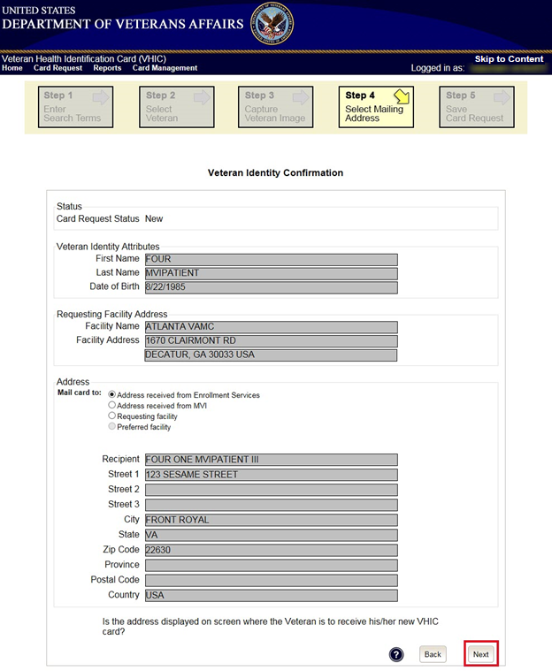

Figure ‑: Select Mailing Address screen

This step provides several mailing options for the card:

* Mail to the address received from Enrollment Services
* Mail to the address received from MVI
* Mail to the requesting facility
* Mail to the preferred facility

*****NOTE:*** *If Enrollment has flagged the Veteran’s address as bad, a message stating why, as well as additional guidance on how to proceed, will be displayed near the top of the screen. At this point, if the Veteran opts to* ***not*** *update their information with ES, the Associate MUST choose one of the remaining viable address options for mailing the card in order to proceed with the card request process.*

*****NOTE:*** *If MVI has flagged the Veteran’s address as bad, a message stating why, as well as additional guidance on how to proceed, will be displayed near the top of the screen. At this point, if the Veteran opts* ***not*** *to update their information with MVI or ES, the Associate MUST choose one of the remaining viable address options for mailing the card in order to proceed with the card request process. Selecting a radio button will automatically update the address information based on the selection. The process cannot continue until the appropriate radio button has been selected*.

*****NOTE:*** *If no preferred facility information has been received from ES or the preferred facility address is flagged as bad, a message stating why, as well as additional guidance on how to proceed, will be displayed near the top of the screen. The Associate MUST choose one of the remaining viable address options for mailing the card in order to proceed with the card request process. Selecting a radio button will automatically update the address information based on the selection. The process cannot continue until the appropriate radio button has been selected*.

Selecting a radio button will automatically update the address information based on the selection. The process cannot continue until the appropriate radio button has been selected.

If the address for the Requesting Facility is not correct, then the VHIC user would need to request help with correcting the address by calling the Enterprise Service Desk at 855-673-4357, option 3, option 3. Alternately, send an email message to ESD DEV OPS [(ESD@va.gov)](mailto:ESD@va.gov) with correction details.

If the information on the screen is a correct match, select the **[Next]** button in the lower right hand to move forward.

### Status Section

At the top of the Step 4 screen is the Status section. When going through the card request process, one of the following Card Request Status options will be displayed: *New*, *Replacement*, or *On Hold*. Since this is a new card request the status displayed is *New*.

### Step 5: Save Card Request

Step 5 – Save Card Request – gives the VHIC user and the Veteran one more opportunity to review all of the information on the screen for accuracy.

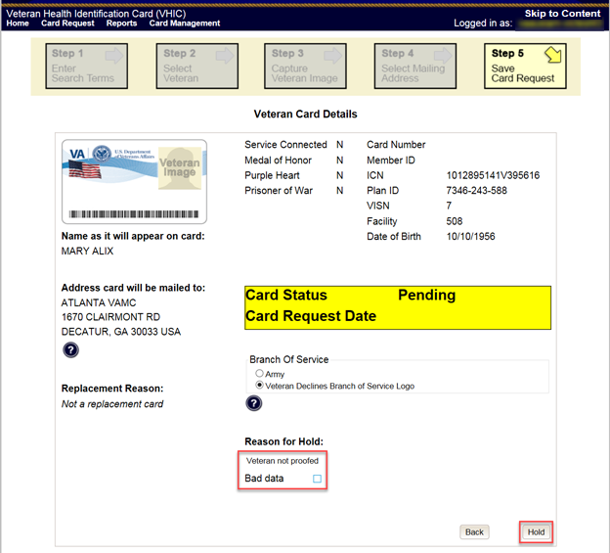

Figure ‑: Save Card Request review screen

This screen contains the following information for review:

* Name as it will appear on card
* Address card will be mailed to (*this also contains the name as it will appear in the mailing address*)
* Replacement reason (*if applicable*)
* Reason for hold (*if applicable*)
* Service connected status
* Medal of Honor status
* Purple Heart status
* Prisoner of War status
* Branch of Service selection
* Date of Birth

Other fields that either will be populated or will populate upon final submission are:

* Card Number (*populates upon final submission*)
* Member ID
* ICN
* Member Benefit Plan ID
* VISN and Facility where request is being processed

#### Branch of Service

If available, the Veteran’s Branch of Service options will be displayed on screen. The Veteran should be given the opportunity to select which logo they would prefer to appear on their card or if they would like to decline the logo option altogether (*default*). The appropriate radio button should be selected based upon the Veteran’s preference. Only those branches of service that are listed in the Enrollment System and in which the Veteran has served will be shown. This will need to be chosen before submitting the card request.

**

***NOTE:*** *Only one Branch of Service logo can appear on the card; those with more than one branch will have to select one, or decline to show any logo.*



Figure ‑: Branch of Service Selection

#### Save Card Request: New

If the card is a new request, meaning the Veteran has never had a VHIC prior to this request; the Replacement Reason section will state the following: *Not a replacement card*.

Since this Veteran has **NOT** had their Identity Proofing completed in the Identity Management Toolkit prior to starting the card request process, the Reason for Hold section will state the following: *Veteran Not Proofed*. The VHIC user will only be presented with the ***[Back]*** and ***[Hold]*** buttons.

Upon submission, a *Card Number* will be generated as well as the *Card Request Date*. The colored field will change from yellow to orange and the corresponding Card Status will change from *Pending* to *Saved on Hold*.

Since the Veteran that this card request was for still needs to be proofed, the VHIC system will display the message below that will include the next steps that the VHIC clerk will need to follow to complete the proofing process.

**IMPORTANT:** This Veteran still needs to have their Identity Proofing completed.

Follow the steps below:

1. Copy the Veteran's ICN above and click here to open the [Identity Management Toolkit](https://mvitkssoi-prod.aac.va.gov/imdquiWeb/login.do) in another window.
2. Complete Proofing for the Veteran in Identity Management Toolkit.
3. Enter Veteran's ICN on Step 1 of the VHIC Card Request Process.
4. Complete card request process and submit.

The words [Identity Management Toolkit](https://mvitkssoi-prod.aac.va.gov/imdquiWeb/login.do) are a hyperlink that the VHIC user can click on to be able to open the Identity Management Toolkit application in another browser window.

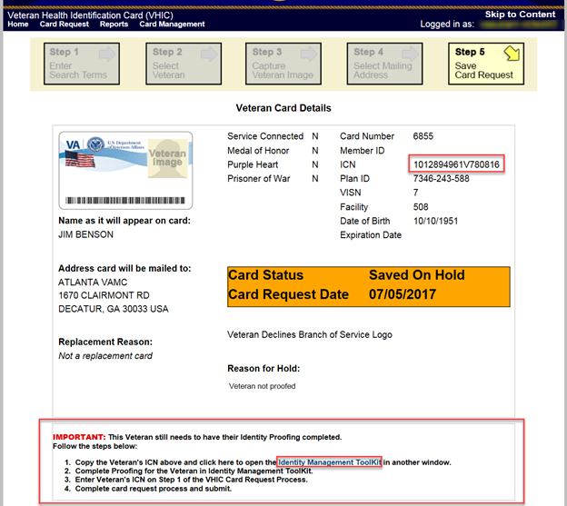

Figure ‑: Card Request Saved on Hold – Veteran Not Proofed

## Resuming an On-Hold VHIC Request: Veteran NOT Level 2 Proofed Hold Reason

When the Associate resumes a card request that has been placed On Hold, they will still be taken through the same steps as though it was a New Card or a Replacement. The Associate won’t be shown that this is an On-Hold Request until they get to Step 4.

### Step 1: Enter Search Terms

The first step in the process is to find the Veteran in the system. This is accomplished by entering enough search criteria to trigger a match within Master Veteran Index (MVI). The top of the screen offers guidance regarding the set of traits recommended to ensure a best match is found. These are guidelines and not necessarily the required set of traits that must be entered.

However, for optimal search results, copy the Veteran’s ICN from the Identity Management Toolkit and paste it into the ICN field on this screen.

Other search methods include:

* The Member ID from the front of the Veteran’s VHIC.
* Last Name, First Name, DOB and SSN.

***NOTE:*** *If using LN/FN/DOB/SSN combination, at a minimum, supply the Veteran's Last Name, plus values from at least two of the other three sections (Person, Address, and Identification).*

The more traits entered, the more likely a match will be returned. Additional guidance is also available on-screen by clicking on the blue circle containing a question mark.



Figure ‑: Help icon

This type of help is available throughout the application and will provide additional detail or clarification for that particular step or section.

Since the VHIC user would have just completed the Identity Proofing process in the Identity Management Toolkit application, the VHIC user can paste the Veteran’s ICN in this screen that was copied from Identity Management Toolkit, then click on **[Search]** to proceed to the next step.

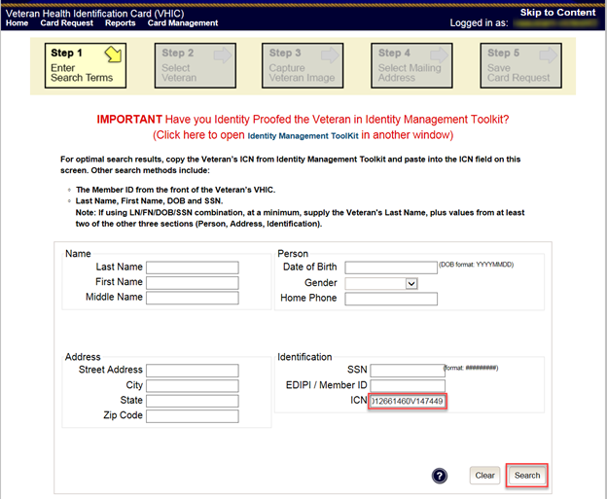

Figure ‑: Enter Search Terms screen

### Step 2: Select Veteran

Once the search has completed, the results of that search will be displayed on screen. From the list provided (up to 10 matches may be returned), select the appropriate Veteran by clicking on the Veteran’s name which is hyperlinked.

If the correct Veteran is not in the list, click the **[Back]** button and verify the traits entered are correct. If the traits are correct, try adding additional information to aid in triggering a match.

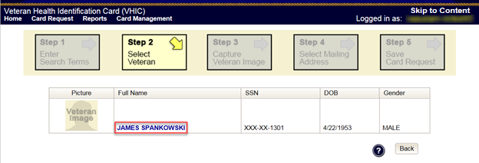

Figure ‑: Select Veteran screen

### Reuse Existing Image

In the event the Veteran has an existing photo in the system that is less than ten years old, this will appear in the image capture area upon entry to Step 3. If this image meets the required guidelines, it may be reused for the current card request process. Simply click **[Next]** to continue on to Step 4.

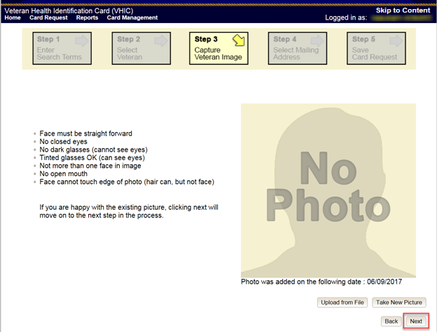

Figure ‑: Capture Veteran Image screen – Reuse Existing Photo; click Next

VHIC will then ask the user to confirm that they want to reuse the existing photo and then they would click **[OK]** to continue on to the next step.

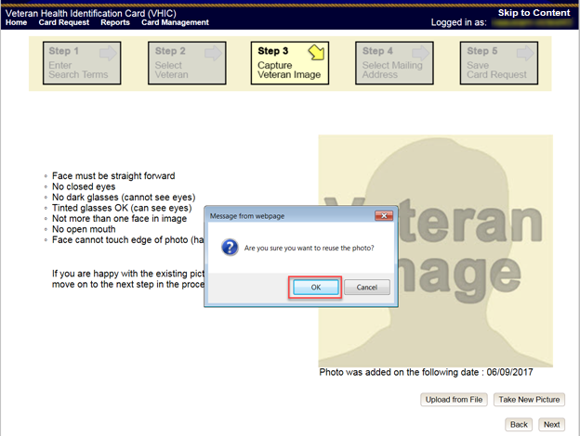

Figure ‑: Capture Veteran Image screen – Reuse Existing Photo; click OK

### Step 4: Select Mailing Address

This screen displays the information retrieved from the Master Veteran Index (MVI) and the Enrollment System (ES) for the selected Veteran. The purpose of this screen is to determine where the Veteran’s card should be mailed.

At the top of the Step 4 screen is the Status section. Since this card request for the Veteran was placed on hold due to Veteran Not Proofed, the status of *On-Hold* will be listed along with the On Hold reason of *Veteran Not Proofed*.

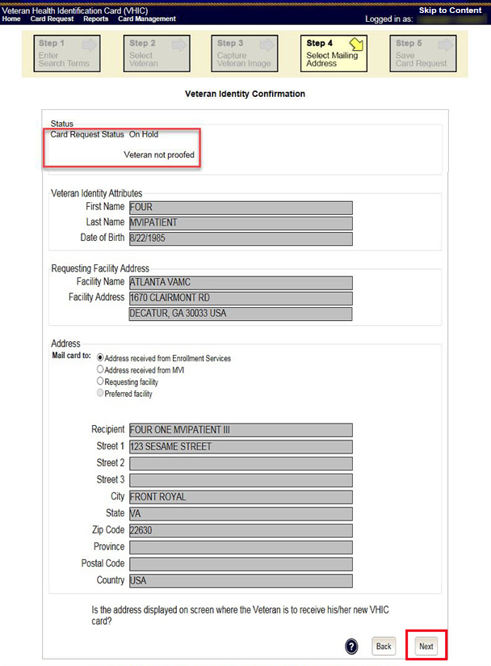

Figure ‑: Select Mailing Address screen

This step provides several mailing options for the card:

* Mail to the address received from Enrollment Services
* Mail to the address received from MVI
* Mail to the requesting facility
* Mail to the Preferred Facility

*****NOTE:*** *If Enrollment has flagged the Veteran’s address as bad, a message stating why, as well as additional guidance on how to proceed, will be displayed near the top of the screen. At this point, if the Veteran opts* ***not*** *to update their information with ES, the Associate MUST choose one of the remaining viable address options for mailing the card in order to proceed with the card request process.*

*****NOTE:*** *If MVI has flagged the Veteran’s address as bad, a message stating why, as well as additional guidance on how to proceed, will be displayed near the top of the screen. At this point, if the Veteran opts* ***not*** *to update their information with MVI or ES, the Associate MUST choose one of the remaining viable address options for mailing the card in order to proceed with the card request process. Selecting a radio button will automatically update the address information based on the selection. The process cannot continue until the appropriate radio button has been selected*.

*****NOTE:*** *If no preferred facility information has been received from ES or the preferred facility address is flagged as bad, a message stating why, as well as additional guidance on how to proceed, will be displayed near the top of the screen. The Associate MUST choose one of the remaining viable address options for mailing the card in order to proceed with the card request process. Selecting a radio button will automatically update the address information based on the selection. The process cannot continue until the appropriate radio button has been selected*.

Selecting a radio button will automatically update the address information based on the selection. The process cannot continue until the appropriate radio button has been selected.

If the address for the Requesting Facility is not correct, then the VHIC user would need to request help with correcting the address by contacting the Enterprise Service Desk at (855) 673-4357, option 3 (Applications), then option 1. Alternately, send an email message to ESD DEV OPS [(ESD@va.gov)](mailto:ESD@va.gov) with correction details.

If the information on the screen is a correct match, select the **[Next]** button in the lower right hand to move forward.

### Status Section

At the top of the Step 4 screen is the Status section. Since this card request for the Veteran was placed on hold, the status of *On Hold* will be listed along with the On Hold reason.

### Step 5: Save Card Request

This brings us to Step 5 – Save Card Request. This screen allows the VHIC User to verify all of the information shown on the screen as being correct.

This screen contains the following information for review:

* Name as it will appear on card
* Address card will be mailed to (*this also contains the name as it will appear in the mailing address*)
* Replacement reason (*if applicable*)
* Reason for hold (*if applicable*)
* Service connected status
* Medal of Honor status
* Purple Heart status
* Prisoner of War status
* Branch of Service selection
* Date of Birth

Other fields that either will be populated or will populate upon final submission are:

* Card Number (*populates upon final submission*)
* Member ID
* ICN
* Member Benefit Plan ID
* VISN and Facility where request is being processed

#### Branch of Service

If available, the Veteran’s Branch of Service options will be displayed on screen. The Veteran should be given the opportunity to select which logo they would prefer to appear on their card or if they would like to decline the logo option altogether (*default*). The appropriate radio button should be selected based upon the Veteran’s preference. Only those branches of service that are listed in the Enrollment System and in which the Veteran has served will be shown. This will need to be chosen before submitting the card request.

**

***NOTE:*** *Only one Branch of Service logo can appear on the card; those with more than one branch will have to select one, or decline to show any logo.*



Figure ‑: Branch of Service Selection

If a Branch of Service option is available to the Veteran, the VHIC associate will see that on this screen and will need to ask the Veteran’s preference for which, if any, BoS they would like to appear on the card.

The VHIC user can now click **[Submit]** to complete the card request.

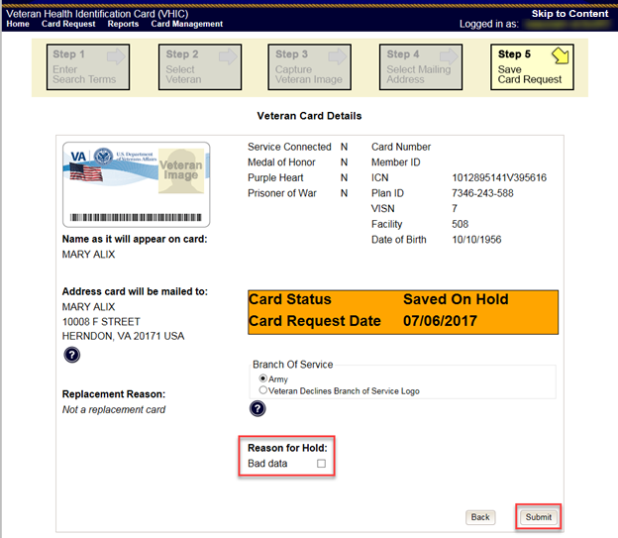

Figure ‑: Save Card Request review screen; click Submit

This screen shows that the Card Request was submitted successfully.

If a Branch of Service was selected on the previous screen. The designated choice will appear here, as well as the Expiration Date and the Replacement Reason.

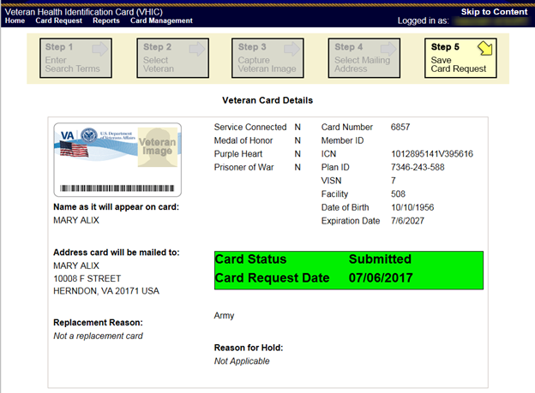

Figure ‑: Card Request Submitted

## Replacement VHIC: Veteran Level 2 Proofed through Identity Management Toolkit

### Step 1: Enter Search Terms

The first step in the process is to find the Veteran in the system. This is accomplished by entering enough search criteria to trigger a match within Master Veteran Index (MVI). The top of the screen offers guidance regarding the set of traits recommended to ensure a best match is found. These are guidelines and not necessarily the required set of traits that must be entered.

However, for optimal search results, copy the Veteran’s ICN from the Identity Management Toolkit and paste it into the ICN field on this screen.

Other search methods include:

* The Member ID from the front of the Veteran’s VHIC.
* Last Name, First Name, DOB and SSN.



***NOTE:*** *If using LN/FN/DOB/SSN combination, at a minimum, supply the Veteran's Last Name, plus values from at least two of the other three sections (Person, Address, and Identification).*

The more traits entered, the more likely a match will be returned. Additional guidance is also available on-screen by clicking on the blue circle containing a question mark.



Figure ‑: Help icon

This type of help is available throughout the application and will provide additional detail or clarification for that particular step or section.

Once the information has been entered into the required fields, click on **[Search]** to proceed to the next step.

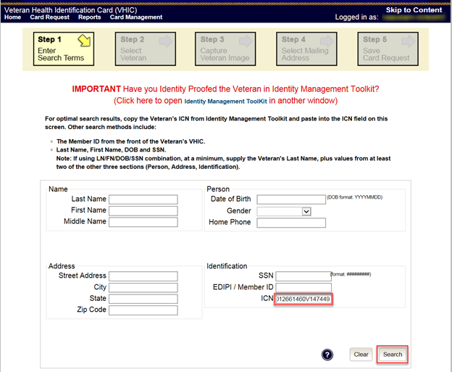

Figure ‑: Enter Search Terms screen

### Step 2: Select Veteran

Once the search has completed, the results of that search will be displayed on screen. From the list provided (up to 10 matches may be returned), select the appropriate Veteran by clicking on the Veteran’s name which is hyperlinked.

If the correct Veteran is not in the list, click the **[Back]** button and verify the traits entered are correct. If the traits are correct, try adding additional information to aid in triggering a match.

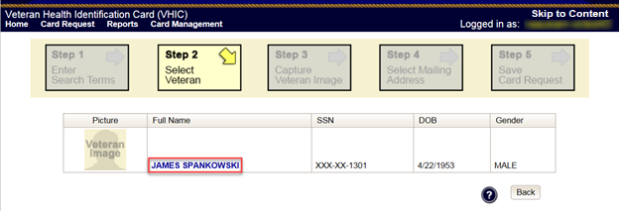

Figure ‑: Select Veteran screen

### Step 3: Capture Veteran Image

Once a selection has been made, the next step in the process is to capture the Veteran image. VHIC provides several ways to handle this operation: Take New Picture, Upload from file, or Reuse Existing Image.

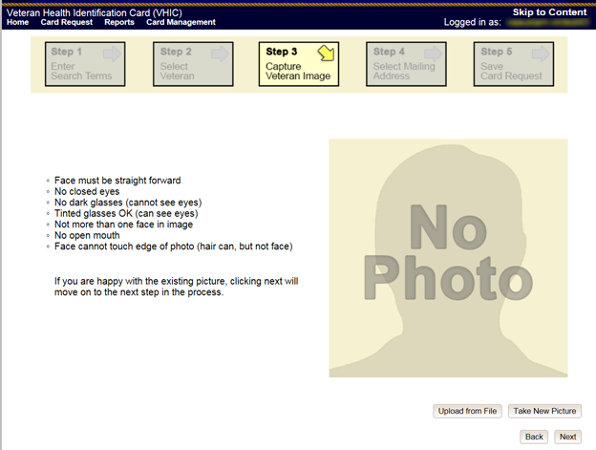

Figure ‑: Step 3 - Capture Veteran Image screen

#### Take New Picture

Upon arriving to the Capture Veteran Image page, if there is no useable image for the Veteran already on file, a “No Photo” image will appear in the image capture area. Click **[Take New Picture]** to capture the Veteran’s image. The camera should become active and the Veteran should be visible in the image capture window. (If the Veteran and background is not visible, refer to section 8.4.3. Adobe Flash Permissions of the VHIC User Guide - Volume 4 - Troubleshooting to ensure your camera settings are correct.)

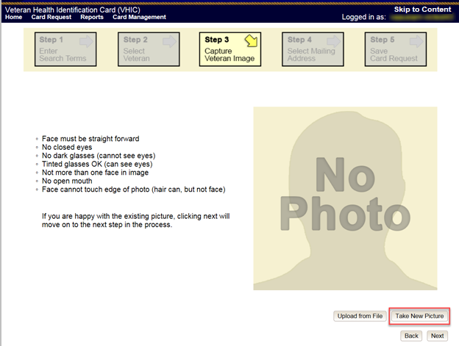

Figure ‑: Capture Veteran Image screen – Take New Picture

Using the provided silhouette, ensure that that the Veteran is lined up properly. Prior to clicking **[Capture Image]** ensure the additional image capture guidelines provided on screen are met:

* Face must be straight forward
* No closed eyes
* No dark glasses (cannot see eyes)
* Tinted glasses OK (can see eyes)
* Not more than one face in image
* No open mouth
* Face cannot touch edge of photo (hair can, but not face)

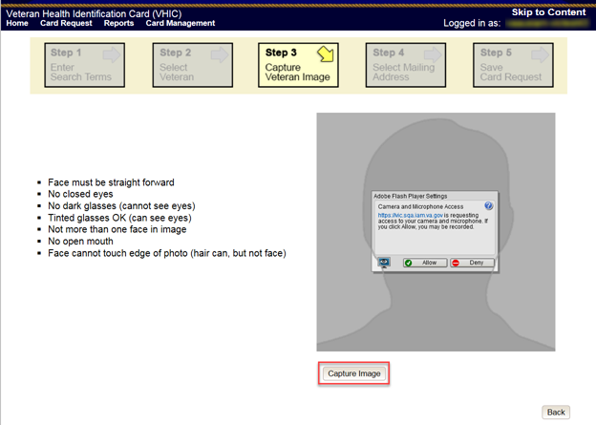

Figure ‑: Capture Veteran Image screen – Capture Image

Once the image is captured, take a moment to review that the image meets all desired guidelines before proceeding. If the image is acceptable, click **[Next]** to continue on to the next step.

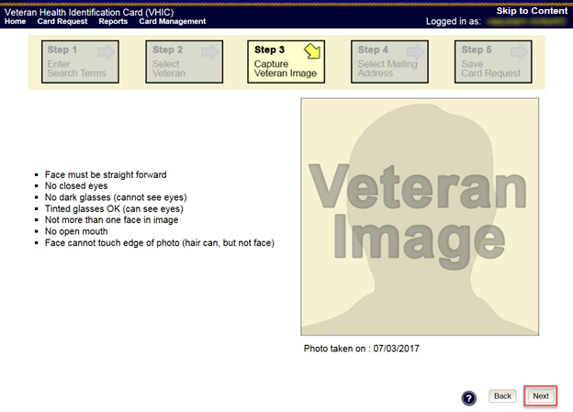

Figure ‑: Capture Veteran Image screen – Accept new photo; click Next

***NOTE:*** *If the image does not meet the guidelines or the Veteran would prefer a new photo be taken or uploaded, this can be done at this point as well by clicking the* ***[Back]*** *button to take a new picture or upload a photo.*

#### Upload from File

In some cases, it may be necessary to upload an image for a Veteran (i.e., they are unable to be present during the card request process due to health issues, etc.) In these cases, VHIC offers the option to upload a photo by selecting the **[Upload from File]** option.

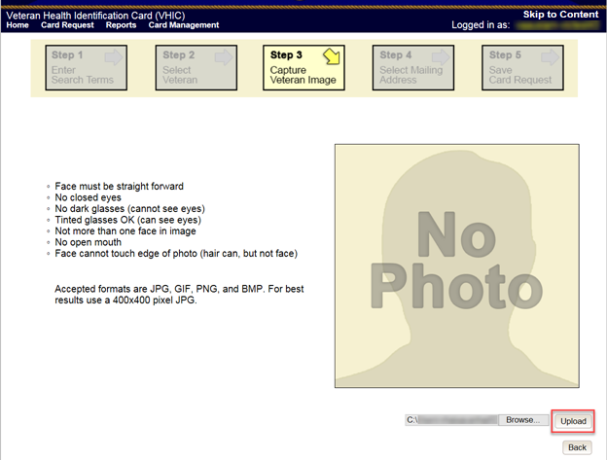

Figure ‑: Capture Veteran Image screen – Upload from File

Once this option is selected, a **[Browse…]** button will appear next to a text field. Clicking this button will open up another window to allow for the desired image to be located and selected. The accepted file formats are JPG, GIF, PNG, and BMP. For best results use a 400x400 pixel JPG image. It should also be noted that any adjustments that need to be made to the image to meet the specified guidelines, such as crop and resize, this should be done before the image is uploaded.

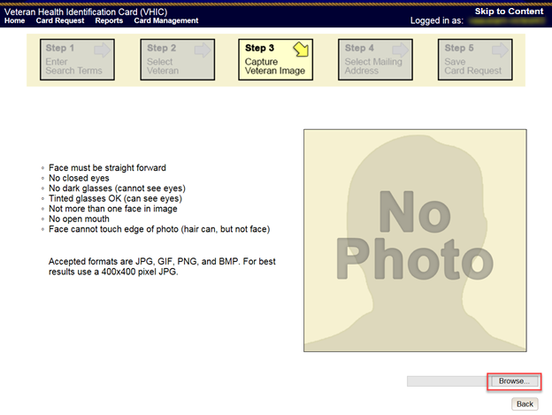

Figure ‑: Capture Veteran Image screen – Upload photo; click Browse

Once the file has been selected, an **[Upload]** button will become available. Clicking this will import the image and it will now be visible in the image capture area.

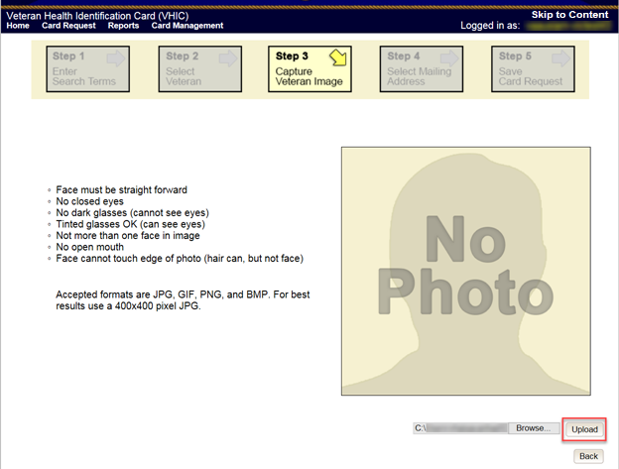

Figure ‑: Capture Veteran Image screen – Upload photo; click Upload

The user can move the slider below the image window to zoom the image in or out to match the silhouette, the image can also be dragged to line the Veteran’s face inside the silhouette as well.

Once again, be sure to review the image to ensure it meets the specified guidelines before clicking the **[Next]** button to continue.

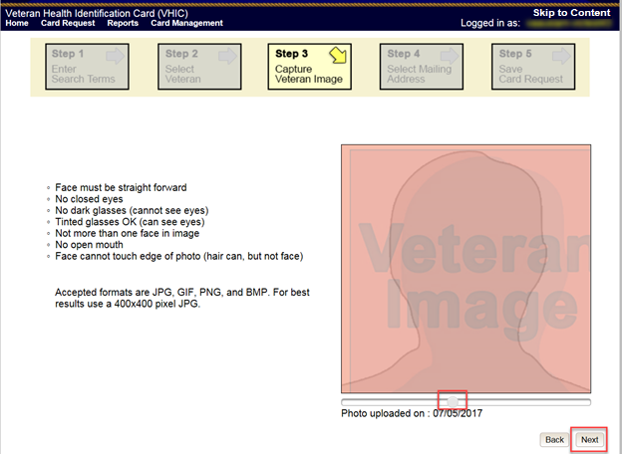

Figure ‑: Capture Veteran Image screen – Edit photo; click Next

#### Reuse Existing Image

In the event the Veteran has an existing photo in the system that is less than ten years old, this will appear in the image capture area upon entry to Step 3. If this image meets the required guidelines, it may be reused for the current card request process. Simply click **[Next]** to continue on to Step 4.

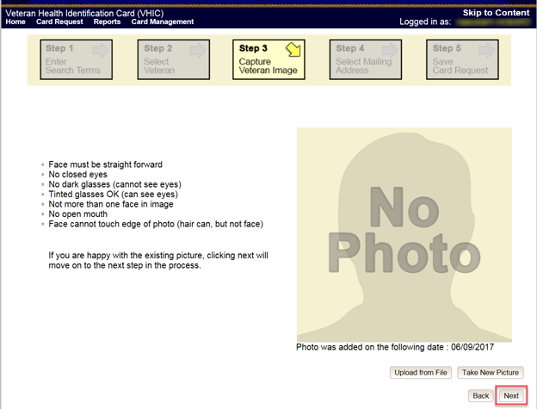

Figure ‑: Capture Veteran Image screen – Reuse Existing Photo; click Next

The VHIC application will ask the user to confirm that they want to reuse the existing photo for this Veteran. Click the **[OK]** button to continue to Step 4: Verify Identity Attributes.

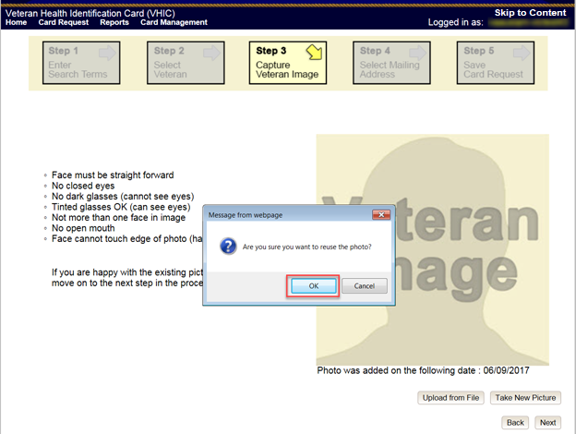

Figure ‑: Capture Veteran Image screen – Reuse Existing Photo; click OK

***NOTE:*** *If the image does not meet the guidelines or the Veteran would prefer a new photo be taken or uploaded, this can be done at this point as well by selecting either* ***[Upload from File]*** *or* ***[Take New Picture]****.*

### Step 4: Verify Identity Attributes

This screen displays the information retrieved from the Master Veteran Index (MVI) and the Enrollment System (ES) for the selected Veteran. The purpose of this screen is to determine where the Veteran’s card should be mailed.

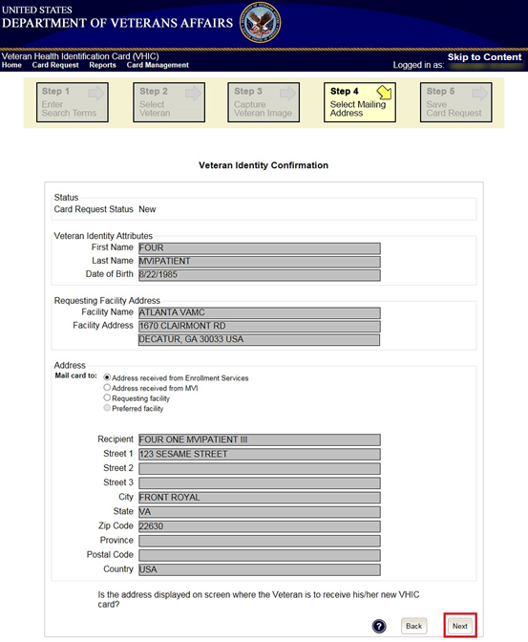

Figure ‑: Select Mailing address screen

This step provides several mailing options for the card:

* Mail to the address received from Enrollment Services
* Mail to the address received from MVI
* Mail to the requesting facility
* Mail to the Preferred Facility

*****NOTE:*** *If Enrollment has flagged the Veteran’s address as bad, a message stating why, as well as additional guidance on how to proceed, will be displayed near the top of the screen. At this point, if the Veteran opts to* ***not*** *update their information with ES, the Associate MUST choose one of the remaining viable address options for mailing the card in order to proceed with the card request process.*

*****NOTE:*** *If MVI has flagged the Veteran’s address as bad, a message stating why, as well as additional guidance on how to proceed, will be displayed near the top of the screen. At this point, if the Veteran opts* ***not*** *to update their information with MVI or ES, the Associate MUST choose one of the remaining viable address options for mailing the card in order to proceed with the card request process. Selecting a radio button will automatically update the address information based on the selection. The process cannot continue until the appropriate radio button has been selected*.

*****NOTE:*** *If no preferred facility information has been received from ES or the preferred facility address is flagged as bad in the VHIC system, a message stating why, as well as additional guidance on how to proceed, will be displayed near the top of the screen. The Associate MUST choose one of the remaining viable address options for mailing the card in order to proceed with the card request process. Selecting a radio button will automatically update the address information based on the selection. The process cannot continue until the appropriate radio button has been selected*.

Selecting a radio button will automatically update the address information based on the selection. The process cannot continue until the appropriate radio button has been selected.

If the address for the Requesting Facility is not correct, then the VHIC user would need to request help with correcting the address by contacting the Enterprise Service Desk at (855) 673-4357, option 3 (Applications), then option 1. Alternately, send an email message to ESD DEV OPS [(ESD@va.gov)](mailto:ESD@va.gov) with correction details.

If the information on the screen is a correct match, select the **[Next]** button in the lower right hand to move forward.

### Status Section

At the top of the Step 4 screen is the Status section. When going through the card request process, one of the following Card Request Status options will be displayed: *New*, *Replacement*, or *On Hold*. If the card was previously placed on hold, the reason it was placed on hold will be listed here as well. If this is not the first card for the Veteran, the status of *Replacement* will be listed along with a drop down list for selecting a *Replacement Reason*.

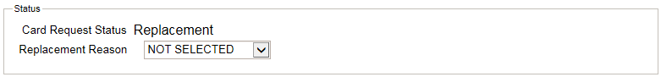

Figure ‑: Card Request Status section

If the *Card Request Status* is *Replacement*, a selection must be made from the drop down list as to why the card is being replaced. The available options are: *Damaged*, *Expired*, *Incorrect* *Information*, *Lost*, *Poor* *Quality*, or *Stolen*.

#### Replacement Options

If the Card Request Status is *Replacement*, a Replacement Reason will have to be provided before the card request process can continue. Based on the primary replacement reason selected, a secondary reason may need to be provided. The options selected here will appear on the final Step 5 screen under *Replacement Reason*.

The following are the available primary replacement reasons:

* Damaged
* Deactivated
* Expired
* Incorrect information
* Lost
* Poor Quality
* Stolen

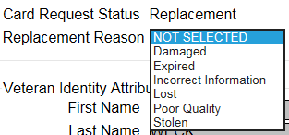

Figure ‑: Replacement Reason drop-down list

If *Poor Quality* is selected as a primary replacement reason, one of the following must be selected:

* Photo
* Text
* Other

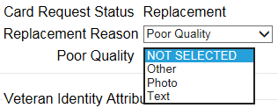

Figure ‑: Poor Quality Replacement Reasons

If *Damaged* is selected as a primary replacement reason, one of the following must be selected:

* Barcode not working
* Magnetic stripe not working
* Other physical damage

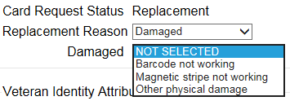

Figure ‑: Damaged Replacement Reasons

If *Incorrect Information* is selected as a primary replacement reason, one of the following must be selected:

* Branch of Service
* Date of Birth
* Member ID
* ICN
* Member Benefit Plan ID
* Name
* Photo
* Prisoner of War
* Purple Heart
* Service Connected
* Other

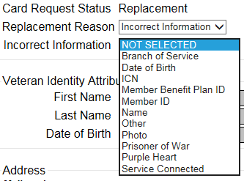

Figure ‑: Incorrect Information Replacement Reasons

### Step 5: Save Card Request

This brings us to Step 5 – Save Card Request. This screen allows the VHIC Admin to verify all of the information shown on the screen as being correct.

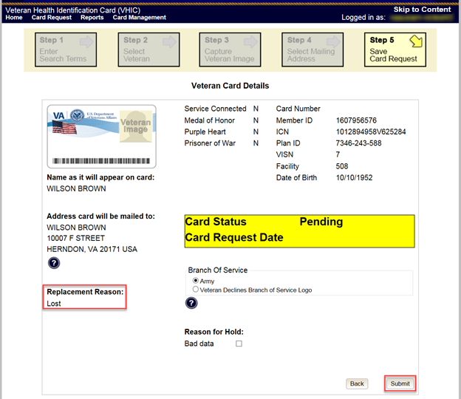

Figure ‑: Save Card Request review screen

This screen contains the following information for review:

* Name as it will appear on card
* Address card will be mailed to (*this also contains the name as it will appear in the mailing address*)
* Replacement reason (*if applicable*)
* Reason for hold (*if applicable*)
* Service connected status
* Medal of Honor status
* Purple Heart status
* Prisoner of War status
* Branch of Service selection
* Date of Birth

Other fields that either will be populated or will populate upon final submission are:

* Card Number (*populates upon final submission*)
* Member ID
* ICN
* Member Benefit Plan ID
* VISN and Facility where request is being processed

#### Branch of Service

If available, the Veteran’s Branch of Service options will be displayed on screen. The Veteran should be given the opportunity to select which logo they would prefer to appear on their card or if they would like to decline the logo option altogether (*default*). The appropriate radio button should be selected based upon the Veteran’s preference. Only those branches of service that are listed in the Enrollment System and in which the Veteran has served will be shown. This will need to be chosen before submitting the card request.

**

***NOTE:*** *Only one Branch of Service logo can appear on the card; those with more than one branch will have to select one, or decline to show any logo.*



Figure ‑: Branch of Service Selection

#### Save Card Request: Replacement

Saving and submitting a replacement card request is essentially the same as submitting a new card request. The only variation will be the replacement reason. The selections made earlier in Step 4 will be reflected on this screen under the Replacement Reason section.

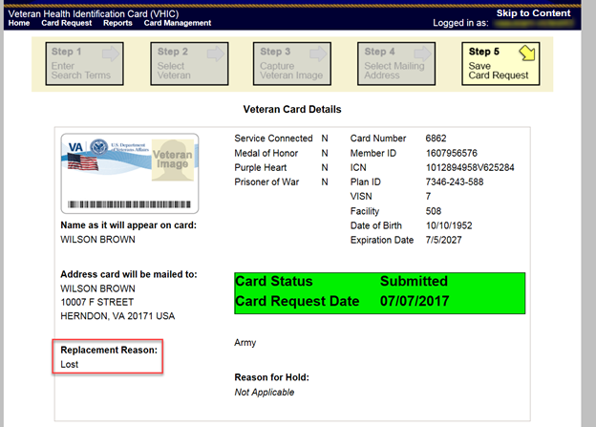

Figure ‑: Replacement Card Request Submitted

## Placing a Replacement VHIC Request On-Hold Manually: Veteran Level 2 Proofed

This section will show how the process flow should go when the VHIC associate enters in a Veteran who is listed in MVI, ES, has a Proofing level of 2 and requesting a new card. During the process the Associate notices some of the Data is not correct.

### Step 1: Enter Search Terms

The first step in the process is to find the Veteran in the system. This is accomplished by entering enough search criteria to trigger a match within Master Veteran Index (MVI). The top of the screen offers guidance regarding the set of traits recommended to ensure a best match is found. These are guidelines and not necessarily the required set of traits that must be entered.

However, for optimal search results, copy the Veteran’s ICN from Identity Management Toolkit and paste it into the ICN field on this screen.

Other search methods include:

* The Member ID from the front of the Veteran’s VHIC.
* Last Name, First Name, DOB and SSN.

***NOTE:*** *If using LN/FN/DOB/SSN combination, at a minimum, supply the Veteran's Last Name, plus values from at least two of the other three sections (Person, Address, and Identification).*

The more traits entered, the more likely a match will be returned. Additional guidance is also available on-screen by clicking on the blue circle containing a question mark.



Figure ‑: Help icon

This type of help is available throughout the application and will provide additional detail or clarification for that particular step or section.

Once the information has been entered into the required fields, click on **[Search]** to proceed to the next step.

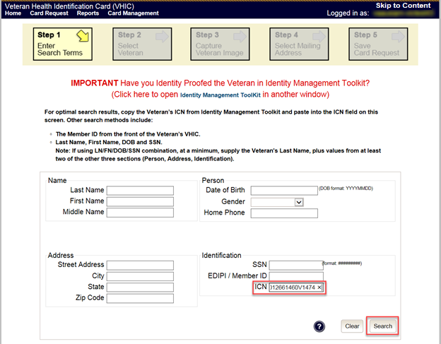

Figure ‑: Enter Search Terms screen

### Step 2: Select Veteran

Once the search has completed, the results of that search will be displayed on screen. From the list provided (up to 10 matches may be returned), select the appropriate Veteran by clicking on the Veteran’s name which is hyperlinked.

If the correct Veteran is not in the list, click the **[Back]** button and verify the traits entered are correct. If the traits are correct, try adding additional information to aid in triggering a match.

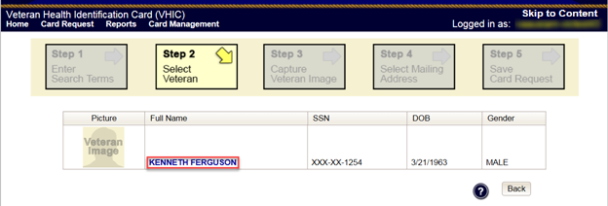

Figure ‑: Select Veteran screen

### Reuse Existing Image

In the event the Veteran has an existing photo in the system that is less than ten years old, this will appear in the image capture area upon entry to Step 3. If this image meets the required guidelines, it may be reused for the current card request process. Simply click **[Next]** to continue on to Step 4.

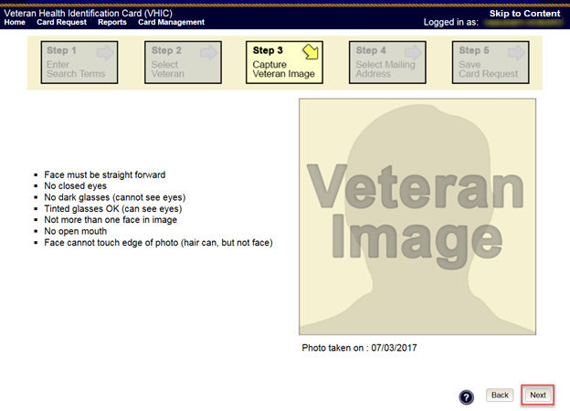

Figure ‑: Capture Veteran Image screen – Reuse Existing Photo; click Next

VHIC will then ask the user to confirm that they want to reuse the existing photo and then they would click **[OK]** to continue on to the next step.

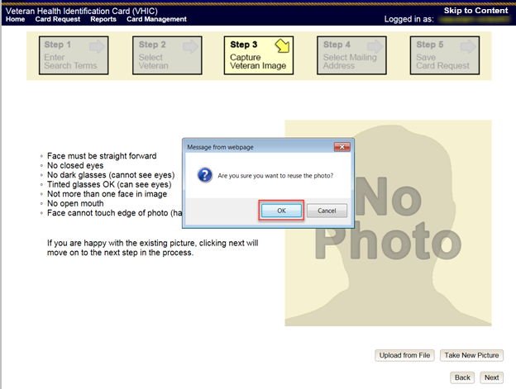

Figure ‑: Capture Veteran Image screen – Reuse Existing Photo; click OK

### Step 4: Select Mailing Address

This screen displays the information retrieved from the Master Veteran Index (MVI) and the Enrollment System (ES) for the selected Veteran. The purpose of this screen is to determine where the Veteran’s card should be mailed.

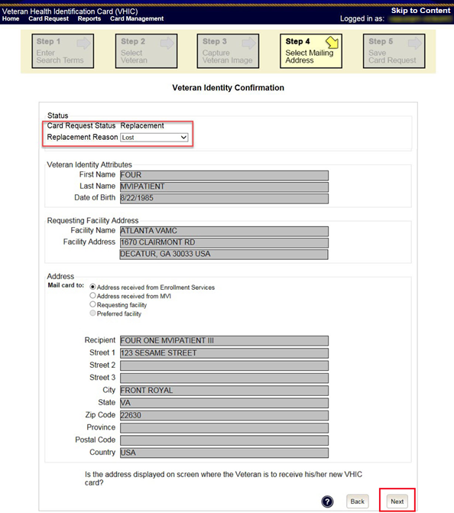

Figure ‑: Select Mailing Address screen

This step provides several mailing options for the card:

* Mail to the address received from Enrollment Services
* Mail to the address received from MVI
* Mail to the requesting facility
* Mail to the Preferred Facility

*****NOTE:*** *If Enrollment has flagged the Veteran’s address as bad, a message stating why, as well as additional guidance on how to proceed, will be displayed near the top of the screen. At this point, if the Veteran opts to* ***not*** *update their information with ES, the Associate MUST choose one of the remaining viable address options for mailing the card in order to proceed with the card request process.*

*****NOTE:*** *If MVI has flagged the Veteran’s address as bad, a message stating why, as well as additional guidance on how to proceed, will be displayed near the top of the screen. At this point, if the Veteran opts* ***not*** *to update their information with MVI or ES, the Associate MUST choose one of the remaining viable address options for mailing the card in order to proceed with the card request process. Selecting a radio button will automatically update the address information based on the selection. The process cannot continue until the appropriate radio button has been selected*.

**

***NOTE:*** *If no preferred facility information has been received from ES or the preferred facility address is flagged as bad, a message stating why, as well as additional guidance on how to proceed, will be displayed near the top of the screen. The Associate MUST choose one of the remaining viable address options for mailing the card in order to proceed with the card request process. Selecting a radio button will automatically update the address information based on the selection. The process cannot continue until the appropriate radio button has been selected*.

Selecting a radio button will automatically update the address information based on the selection. The process cannot continue until the appropriate radio button has been selected.

If the address for the Requesting Facility is not correct, then the VHIC user would need to request help with correcting the address by contacting the Enterprise Service Desk at (855) 673-4357, option 3 (Applications), then option 1. Alternately, send an email message to ESD DEV OPS [(ESD@va.gov)](mailto:ESD@va.gov) with correction details.

If the information on the screen is a correct match, select the **[Next]** button in the lower right hand to move forward.

### Status Section

At the top of the Step 4 screen is the Status section. When going through the card request process, one of the following Card Request Status options will be displayed: *New*, *Replacement*, or *On Hold*. If the card was previously placed on hold, the reason it was placed on hold will be listed here as well. If this is not the first card for the Veteran, the status of *Replacement* will be listed along with a drop down list for selecting a *Replacement Reason*.



Figure ‑: Card Request Status section

If the *Card Request Status* is *Replacement*, a selection must be made from the drop down list as to why the card is being replaced. The available options are: *Damaged*, *Expired*, *Incorrect* *Information*, *Lost*, *Poor* *Quality*, or *Stolen*.

#### Replacement Options

If the Card Request Status should be Replacement, a Replacement Reason will have to be provided before the card request process can continue. Based on the primary replacement reason selected, a secondary reason may need to be provided. The options selected here will appear on the final Step 6 screen under *Replacement Reason*.

The following are the available primary replacement reasons:

* Damaged
* Deactivated
* Expired
* Incorrect information
* Lost
* Poor Quality
* Stolen



Figure ‑: Replacement Reason drop-down list

If *Poor Quality* is selected as a primary replacement reason, one of the following must be selected:

* Photo
* Text
* Other



Figure ‑: Poor Quality Replacement Reasons

If *Damaged* is selected as a primary replacement reason, one of the following must be selected:

* Barcode not working
* Magnetic stripe not working
* Other physical damage



Figure ‑: Damaged Replacement Reasons

If *Incorrect Information* is selected as a primary replacement reason, one of the following must be selected:

* Branch of Service
* Date of Birth
* Member ID
* ICN
* Member Benefit Plan ID
* Name
* Photo
* Prisoner of War
* Purple Heart
* Service Connected
* Other



Figure ‑: Incorrect Information Replacement Reasons

### Step 5: Save Card Request

This brings us to Step 5 – Save Card Request. This screen allows the VHIC Admin to verify all of the information shown on the screen as being correct.

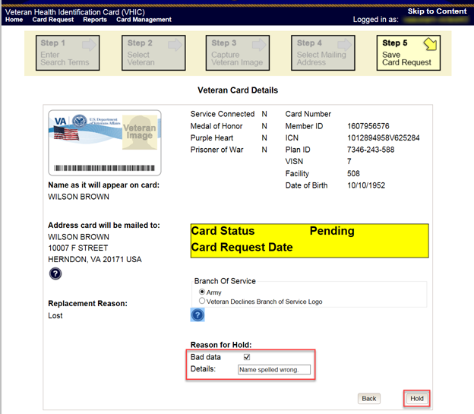

Figure ‑: Save Card Request review screen

This screen contains the following information for review:

* Name as it will appear on card
* Address card will be mailed to (*this also contains the name as it will appear in the mailing address*)
* Replacement reason (*if applicable*)
* Reason for hold (*if applicable*)
* Service connected status
* Medal of Honor status
* Purple Heart status
* Prisoner of War status
* Branch of Service selection
* Date of Birth

Other fields that either will be populated or will populate upon final submission are:

* Card Number (*populates upon final submission*)
* Member ID
* ICN
* Member Benefit Plan ID
* VISN and Facility where request is being processed

If a Branch of Service option is available to the Veteran, the VHIC associate will see that on this screen and will need to ask the Veteran’s preference for which, if any, BoS they would like to appear on the card.

If, after review, the Veteran states that an item is listed incorrectly (i.e., proper Branch of Service is not listed, Medal of Honor status is incorrect, etc.) the VHIC user can check the Bad data checkbox.

When this option is selected, the VHIC user must list the details of the bad data in the provided Details field. This information will be stored in the system and will appear upon submission as well as on Step 4 when this particular request is removed from hold.

The option to Submit is no longer available. Instead the VHIC user will click **[Hold]** to place the card request on hold.

#### Save Card Request: Manually saved On-Hold

Upon submission, the colored field will change from yellow to orange indicating the card request was placed on hold. A Card Number will be generated as well as the Card Request Date.

The Expiration Date field will now be visible, but will not be populated as the card request is not complete at this time. The Card Status is listed as Saved on Hold.

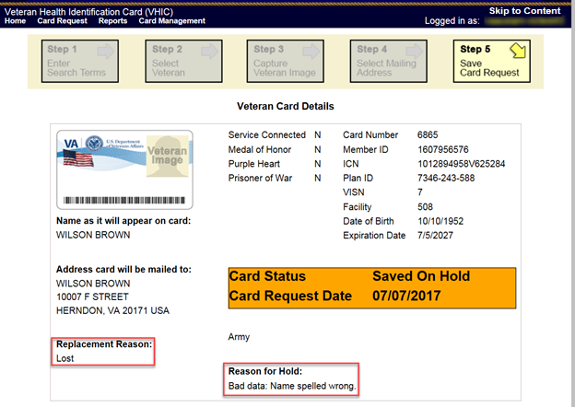

Figure ‑: Replacement Card Request Saved On Hold

## On Hold Reasons Explained

### Veteran Not Proofed

**User did NOT complete the proofing process using the Identity Management Toolkit application PRIOR to creating a VHIC request**

If the VHIC user started the VHIC card request BEFORE going into the Identity Management Toolkit application and completing the proofing process, the VHIC application will display the Warning message on Step 4 of the card request process indicating that the Veteran has NOT been Identity Proofed. The VHIC user will see Veteran not proofed as the Reason for Hold on Step 5. The VHIC application will allow you to save the card request on hold. The card request will be saved for 30 days.

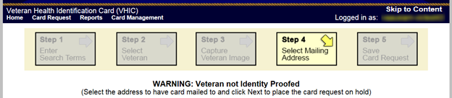

Figure ‑: Veteran Not Proofed Warning message on Step 4: Select Mailing Address

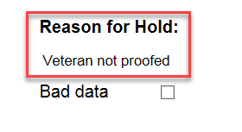

Figure ‑: Reason for Hold: Veteran Not Proofed

Once the VHIC user completes the Identity Proofing in the Identity Management Toolkit application, they can return to the VHIC application to take the card request off hold. The VHIC user will start a card request as they would normally. The VHIC user will see the On Hold Reason – Veteran Not Proofed displayed on Step 4 of the card request process.

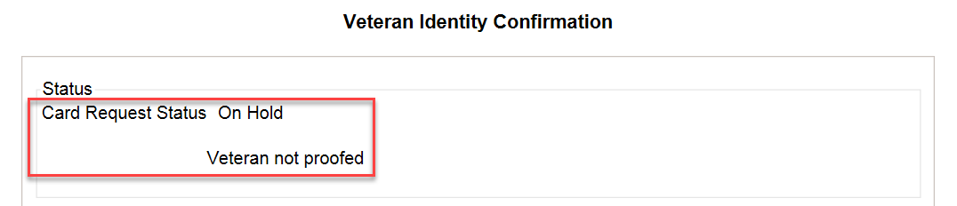

Figure ‑: Card Request Status: On Hold - Veteran Not Proofed

Continue with the card request process and submit the card request as outlined in section 4.3 Resuming an On-Hold VHIC Request: Veteran NOT Level 2 Proofed Hold Reason

*****NOTE:*** *There is a background job that runs every morning at 8:00am Eastern Time that will check the proofing status of any cards placed on hold. As long as there are no other issues with the card request, the job will submit the card request to the print vendor.*

### Enrollment Services Unavailable

If you get to Step 6 and see the message “Enrollment Unavailable” displayed under **Reason for Hold**, which means that VHIC is unable to communicate to Enrollment Services at this time, select the Branch of Service (if available) and click on the **[Hold]** button. This will save the card request for 30 days.

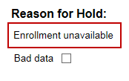

Figure ‑: Reason for Hold: Enrollment Unavailable

Next, log a ticket by calling the Enterprise Service Desk at 855-673-4357, option #3 (Applications), then option #1 or send an email message to ESD DEV OPS ([ESD@va.gov](mailto:ESD@va.gov)) to log a trouble ticket.

*****NOTE:*** *There is a background job that runs every morning at 8:00am Eastern Time that will check the eligibility status of any cards placed on hold.*

* *If the Eligibility status is confirmed as “Eligible” and there are no other issues with the card request, the job will submit the card request to the print vendor.*
* *If the Eligibility status is confirmed as “Not Eligible”, the card request will be terminated and no card will be issued.*

### Eligibility Pending

If you get to Step 6 and see the message “Eligibility Pending” displayed under **Reason for Hold**, which means that Enrollment Services has returned an eligibility status of “Pending” at this time, select the Branch of Service (if available) and click on the **[Hold]** button. This will save the card request for seven (7) days.

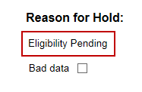

Figure ‑: Reason for Hold: Eligibility Pending

*****NOTE:*** *The Veteran should go to Enrollment Services to have the record updated as needed. There is a background job that runs every morning at 8:00am Eastern Time that will check the eligibility status of any cards placed on hold.*

* *If the Eligibility status is confirmed as “Eligible” and there are no other issues with the card request, the job will submit the card request to the print vendor.*
* *If the Eligibility status is confirmed as “Not Eligible” or is not updated within Seven (7) days, the card request will be terminated and no card will be issued.*

### Bad Data – Other

If you get to Step 6: Save Card Request and any information that is displayed on the screen needs to get changed/updated, click the checkbox next to Bad Data under Reason for Hold. A Details field with be displayed and you can enter a description on what information needs to be updated. Then select the Branch of Service (if available) and click on the **[Hold]** button. This will save the card request for 30 days.

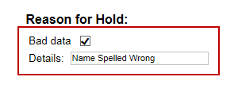

Figure ‑: Reason for Hold: Bad Data – Name Spelled Wrong

The Veteran should go to Enrollment Services to have the record updated as needed. A card request placed on hold with **Bad Data** as the **Reason for Hold** will NOT be updated and submitted by the background job.

The Veteran will need to return to complete the card request after they have had the information updated. You will need to start a card request as you would normally. On Step 4 of the card request process, you will see the On Hold Reason – Bad Data: (reason entered when saved) displayed.

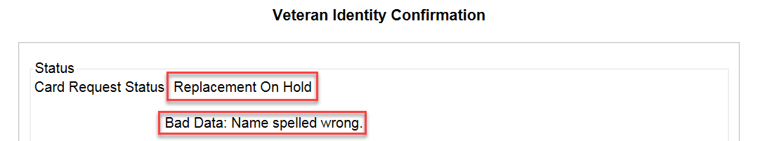

Figure ‑: Card Request Status: Replacement on Hold - Bad Data: Name Spelled Wrong

Continue with the card request process. When you get to Step 6, you will need to uncheck the checkbox next to Bad Data in order to be able to submit the card request.

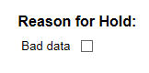

Figure ‑: Reason for Hold: Bad Data Unchecked

## Resuming an On-Hold Replacement VHIC Request: Veteran Level 2 Proofed

When the Associate resumes a card request that has been placed On Hold, they will still be taken through the same steps as though it was a New Card or a Replacement. The Associate won’t be shown that this is an On-Hold Request until they get to Step 4.

### Step 1: Enter Search Terms

The first step in the process is to find the Veteran in the system. This is accomplished by entering enough search criteria to trigger a match within Master Veteran Index (MVI). The top of the screen offers guidance regarding the set of traits recommended to ensure a best match is found. These are guidelines and not necessarily the required set of traits that must be entered.

However, for optimal search results, copy the Veteran’s ICN from Identity Management Toolkit and paste it into the ICN field on this screen.

Other search methods include:

* The Member ID from the front of the Veteran’s VHIC.
* Last Name, First Name, DOB and SSN.



***Note:*** *If using LN/FN/DOB/SSN combination, at a minimum, supply the Veteran's Last Name, plus values from at least two of the other three sections (Person, Address, and Identification).*

The more traits entered, the more likely a match will be returned. Additional guidance is also available on-screen by clicking on the blue circle containing a question mark.



Figure ‑: Help icon

This type of help is available throughout the application and will provide additional detail or clarification for that particular step or section.

Once the information has been entered into the required fields, click on **[Search]** to proceed to the next step.

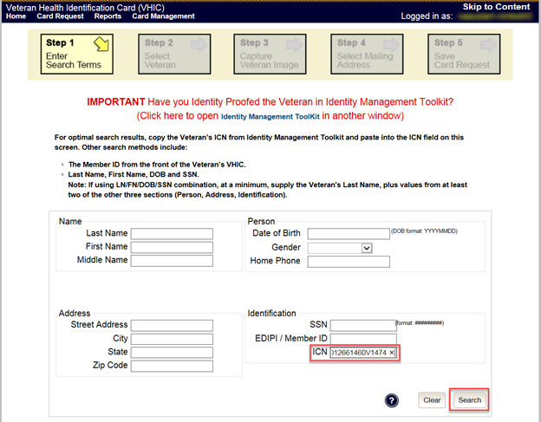

Figure ‑: Enter Search Terms screen

### Step 2: Select Veteran

Once the search has completed, the results of that search will be displayed on screen. From the list provided (up to 10 matches may be returned), select the appropriate Veteran by clicking on the Veteran’s name which is hyperlinked.

If the correct Veteran is not in the list, click the **[Back]** button and verify the traits entered are correct. If the traits are correct, try adding additional information to aid in triggering a match.

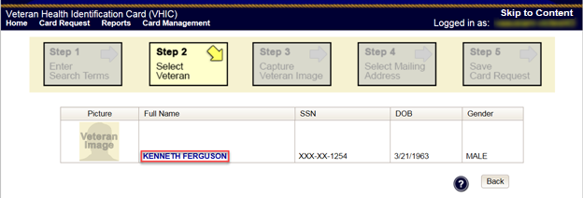

Figure ‑: Select Veteran screen

### Reuse Existing Image

In the event the Veteran has an existing photo in the system that is less than ten years old, this will appear in the image capture area upon entry to Step 3. If this image meets the required guidelines, it may be reused for the current card request process. Simply click **[Next]** to continue on to Step 4.

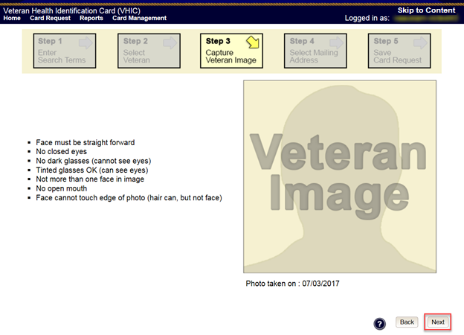

Figure ‑: Capture Veteran Image screen – Reuse Existing Photo; click Next

VHIC will then ask the user to confirm that they want to reuse the existing photo and then they would click **[OK]** to continue on to the next step.

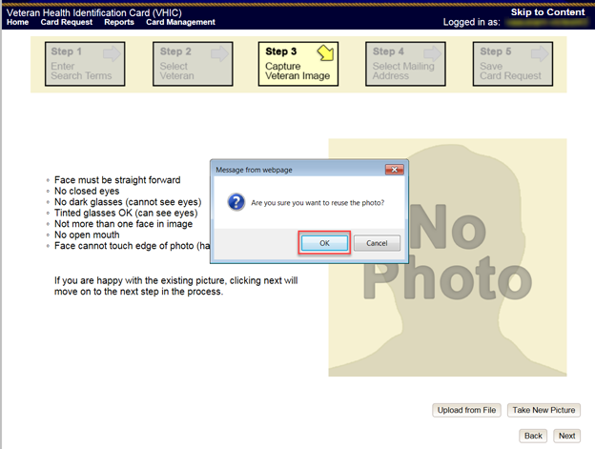

Figure ‑: Capture Veteran Image screen – Reuse Existing Photo; click OK

### Step 4: Select Mailing Address

This screen displays the information retrieved from the Master Veteran Index (MVI) and the Enrollment System (ES) for the selected Veteran. The purpose of this screen is to determine where the Veteran’s card should be mailed.

At the top of the Step 4 screen is the Status section. Since this card request for the Veteran was placed on hold, the status of *Replacement On-Hold* will be listed along with the On Hold reason. There is also a drop down list for selecting a *Replacement Reason*.

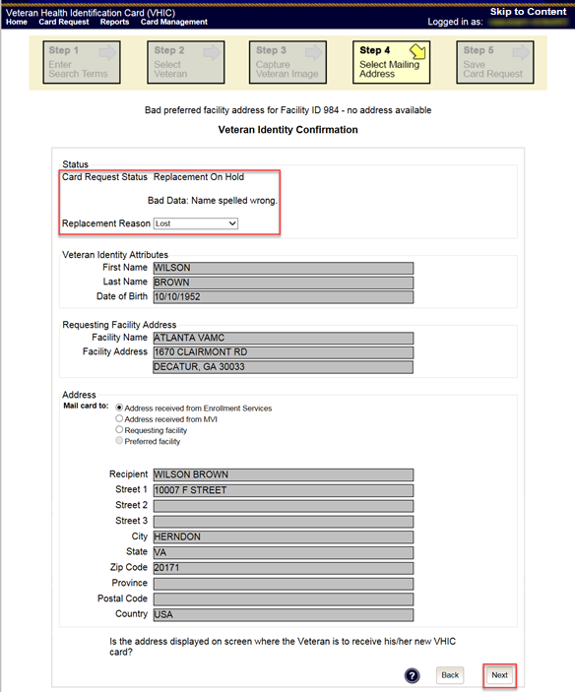

Figure ‑: Select Mailing Address screen

This step provides several mailing options for the card:

* Mail to the address received from Enrollment Services
* Mail to the address received from MVI
* Mail to the requesting facility
* Mail to the Preferred Facility

*****NOTE:*** *If Enrollment has flagged the Veteran’s address as bad, a message stating why, as well as additional guidance on how to proceed, will be displayed near the top of the screen. At this point, if the Veteran opts to* ***not*** *update their information with ES, the Associate MUST choose one of the remaining viable address options for mailing the card in order to proceed with the card request process.*

*****NOTE:*** *If MVI has flagged the Veteran’s address as bad, a message stating why, as well as additional guidance on how to proceed, will be displayed near the top of the screen. At this point, if the Veteran opts* ***not*** *to update their information with MVI or ES, the Associate MUST choose one of the remaining viable address options for mailing the card in order to proceed with the card request process. Selecting a radio button will automatically update the address information based on the selection. The process cannot continue until the appropriate radio button has been selected*.

*****NOTE:*** *If no preferred facility information has been received from ES or the preferred facility address is flagged as bad, a message stating why, as well as additional guidance on how to proceed, will be displayed near the top of the screen. The Associate MUST choose one of the remaining viable address options for mailing the card in order to proceed with the card request process. Selecting a radio button will automatically update the address information based on the selection. The process cannot continue until the appropriate radio button has been selected*.

Selecting a radio button will automatically update the address information based on the selection. The process cannot continue until the appropriate radio button has been selected.

If the address for the Requesting Facility is not correct, then VHIC user would need to request help with correcting the address by calling the Enterprise Service Desk at 855-673-4357, option 3 (Applications), then option 1. Alternately, send an email message to ESD DEV OPS ([ESD@va.gov](mailto:ESD@va.gov)) with correction details.

If the information on the screen is a correct match, select the **[Next]** button in the lower right hand to move forward.

### Status Section

At the top of the Step 4 screen is the Status section. Since this card request for the Veteran was placed on hold, the status of *Replacement On Hold* will be listed along with the On Hold reason. There is also a drop down list for selecting a *Replacement Reason*.

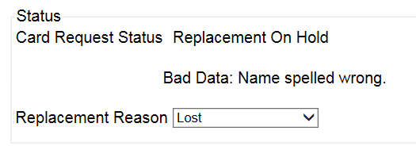

Figure ‑: Card Request Status section

Since the Card Request Status is *Replacement On Hold*, a selection must be made from the drop down list as to why the card is being replaced. The available options are: *Damaged, Expired, Incorrect Information, Lost, Poor Quality,* or *Stolen*.

#### Replacement Options

If the Card Request Status should be Replacement, a Replacement Reason will have to be provided before the card request process can continue. Based on the primary replacement reason selected, a secondary reason may need to be provided. The options selected here will appear on the final Step 6 screen under *Replacement Reason*.

The following are the available primary replacement reasons:

* Damaged
* Deactivated
* Expired
* Incorrect information
* Lost
* Poor Quality
* Stolen



Figure ‑: Replacement Reason drop-down list

If *Poor Quality* is selected as a primary replacement reason, one of the following must be selected:

* Photo
* Text
* Other



Figure ‑: Poor Quality Replacement Reasons

If *Damaged* is selected as a primary replacement reason, one of the following must be selected:

* Barcode not working
* Magnetic stripe not working
* Other physical damage



Figure ‑: Damaged Replacement Reasons

If *Incorrect Information* is selected as a primary replacement reason, one of the following must be selected:

* Branch of Service
* Date of Birth
* Member ID
* ICN
* Member Benefit Plan ID
* Name
* Photo
* Prisoner of War
* Purple Heart
* Service Connected
* Other



Figure ‑: Incorrect Information Replacement Reasons

### Step 5: Save Card Request

This brings us to Step 5 – Save Card Request. This screen allows the VHIC Admin to verify all of the information shown on the screen as being correct.

If a Branch of Service option is available to the Veteran, the VHIC associate will see that on this screen and will need to ask the Veteran’s preference for which, if any, BoS they would like to appear on the card.

If, after review, the Veteran states that all items are listed correctly now, the VHIC user can uncheck the *Bad data* checkbox.

When the *Bad data* checkbox is unchecked, the **[Hold]** button will change to the **[Submit]** button.

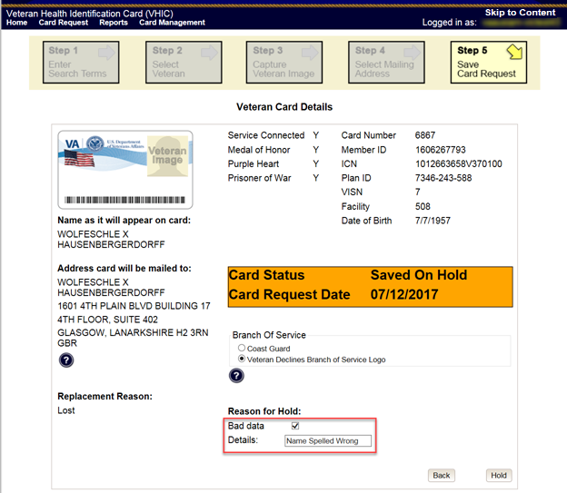

Figure ‑: Save Card Request review screen; Uncheck Bad Data checkbox

The VHIC user can now click **[Submit]** to complete the card request.

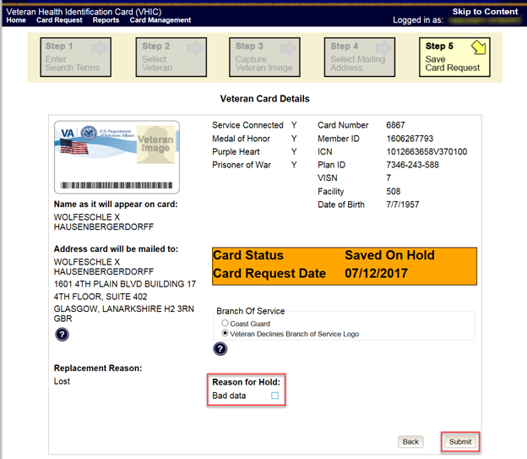

Figure ‑: Save Card Request review screen; click Submit

This screen shows that the Card Request was submitted successfully.

If a Branch of Service was selected on the previous screen. The designated choice will appear here, as well as the Expiration Date and the Replacement Reason.

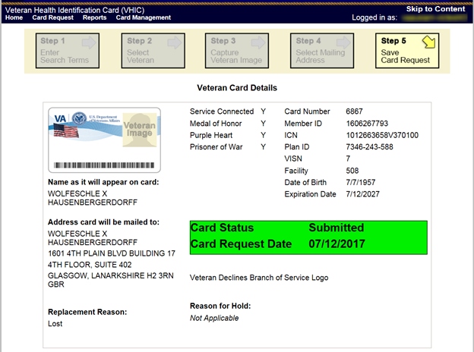

Figure ‑: Replacement Card Request Submitted

## Requesting a VHIC for a Veteran within ten (10) days of a previous VHIC request

VHIC Users will not be able to request a new VHIC for a Veteran if there has been a previous request made within the past ten (10) days. They will be shown a message on Step 2 of the VHIC card request process stating:   
  
“This Veteran has a recent VHIC request in process. Please remind the Veteran the VHIC should be received with 10 days after the request was submitted.”

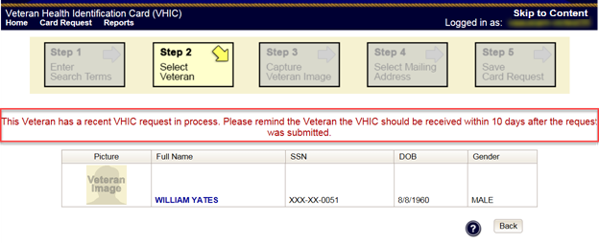

Figure ‑: Replacement Card has been requested within the past 10 days

If for some reason a new VHIC request must be made to include any changes within 10 days of the previous card request, **ONLY** the VHIC Administrator will be able to submit a new card request. In this instance, the VHIC user will need to submit a request to the **VHA HEC VHIC Program Team** mail group via an encrypted message.

Information to include in the request are listed below:

* Veteran’s First and Last Name
* Date of Birth
* SSN
* Site Point of Contact
* Reason for needing a new card requested within 10 days of the previous request.

# Card Deactivations

Card deactivations can **ONLY** be completed by the VHIC Administrator. The VHIC user will need to submit a request to the **VHA HEC VHIC Program Team** mail group via an encrypted message.

Information to include in the request are listed below:

* Veteran’s First and Last Name
* Date of Birth
* SSN
* Card ID Number
* Site Point of Contact
* One of the following deactivation reasons:
  + Cancelled/Declined (enrollment)
  + Damaged
  + Deceased
  + Identity Theft
  + Lost
  + Stolen
  + Other – With detailed explanation

*****NOTE:*** *For Damaged, Lost and Stolen cards, please specify whether a new replacement card should be sent to the Veteran after their current card has been deactivated.*

**VHIC Administrators** can find detailed information on how to deactivate all of the VHICs for a given Veteran in the **Veteran Health Identification Card (VHIC 4.8) User Guide - Volume 3 – Admins** document.

# Reports

A comprehensive walkthrough of all of the different reports that are available to VHIC users and the types of metrics that can be obtained, as well as an explanation of the user role permissions for accessing the reports are included in the **Veteran Health Identification Card (VHIC 4.8) User Guide - Volume 2 - Reports** document.

# Troubleshooting

For a through set of troubleshooting guidelines, please refer to the **Veteran Health Identification Card (VHIC 4.8) User Guide - Volume 4 - Troubleshooting** document.

# Appendix A: VHIC Roles

|  |  |  |  |  |  |  |  |  |  |  |  |  |  |
| --- | --- | --- | --- | --- | --- | --- | --- | --- | --- | --- | --- | --- | --- |
|  | | |  | |  | VHIC Role | | | | | | | |
| Function/Report Title | | | Navigation | | Selected Status from Drop Down Menu | Administrator | Technical Administrator Tier 3 | Supervisor | | Associate | | Auditor | Read-Only User |
| **CARD REQUESTS** | | | | | | | | | | | | | |
| Request Cards | | | (**Card Requests** icon on Home Screen/ **Card Requests** link in top Navigation Bar) | | N/A | X | X | X | | X | |  |  |
| Deactivate Cards | | | (**Card Management** icon on Home Screen/ **Card Management** link in top Navigation Bar) | | N/A | X | X |  | |  | |  |  |
| **REPORTS** | | | | | | | | | | | | | |
| **Veteran** (Direct Search) | | | (**Reports** icon on Home Screen/ **Reports** link in top Navigation Bar) | |  | | | | | | | | |
| Basic (*no national option*) | | | | | | | | | | | | | |
| Veteran Detail Report | | | Default view for Reports | | N/A | X | X | | X | | X | X | X |
| **Card Request Totals** | | | (**Card** menu tab - **Request Totals** sub-menu tab) | |  | | | | | | | | |
| *National* | | | | | | | | | | | | | |
| VHIC Card Request Totals | | | Click National Checkbox | | N/A | X | X | |  | |  | X |  |
| *VISN* | | | | | | | | | | | | | |
| VHIC Card Request Totals | | | Click VISN radio button | | N/A | X | X | |  | |  | X | X |
| *Facility* | | | | | | | | | | | | | |
| VHIC Card Request Totals | | | Click Facility ration button | | N/A | X | X | | X | | X | X | X |
| **Card Status - MVI Status Report** | | | (**Card** menu tab - **Status** sub-menu tab - **MVI Status** radio button) | |  | | | | | | | | |
| *National* | | | | | | | | | | | | | |
| VHIC MVI Status National Report | | | Click National Checkbox | | Active | X | X | |  | |  | X |  |
|  | | |  | | Not Correlated | X | X | |  | |  | X |  |
|  | | |  | | Rejected | X | X | |  | |  | X |  |
|  | | |  | | Unlinked | X | X | |  | |  | X |  |
| *VISN* | | | | | | | | | | | | | |
| VHIC MVI Status Summary Report | | | Click VISN radio button | | Active | X | X | |  | |  | X |  |
|  | | |  | | Not Correlated | X | X | |  | |  | X |  |
|  | | |  | | Rejected | X | X | |  | |  | X |  |
|  | | |  | | Unlinked | X | X | |  | |  | X |  |
| *Facility* | | | | | | | | | | | | | |
| VHIC MVI Status Summary Report | | | Click Facility ration button | | Active | X | X | | X | | X | X |  |
|  | | |  | | Not Correlated | X | X | | X | | X | X |  |
|  | | |  | | Rejected | X | X | | X | | X | X |  |
|  | | |  | | Unlinked | X | X | | X | | X | X |  |
| *Facility Detail* | | | | | | | | | | | | | |
| VHIC MVI Status Detail Report | | | Click on the Facility Number | | Active | X | X | | X | | X | X |  |
|  | | |  | | Not Correlated | X | X | | X | | X | X |  |
|  | | |  | | Rejected | X | X | | X | | X | X |  |
|  | | |  | | Unlinked | X | X | | X | | X | X |  |
|  | | |  | |  |  |  | |  | |  |  |  |
| **Card Status - Card Status Report** | | | (**Card** menu tab - **Status** sub-menu tab - **Card Status** radio button) | |  | | | | | | | | |
| *National* | | | | | | | | | | | | | |
| VHIC Card Status National Report | | | Click National Checkbox | | Replaced | X | X | |  | |  | X |  |
|  | | |  | | Deactivated | X | X | |  | |  | X |  |
|  | | |  | | Expired | X | X | |  | |  | X |  |
|  | | |  | | On Hold | X | X | |  | |  | X |  |
|  | | |  | | Pending | X | X | |  | |  | X |  |
|  | | |  | | Requested | X | X | |  | |  | X |  |
|  | | |  | | Defunct | X | X | |  | |  | X |  |
|  | | |  | | Pending Destruction | X | X | |  | |  | X |  |
|  | | |  | | Destroyed | X | X | |  | |  | X |  |
| *VISN* | | | | | | | | | | | | | |
| VHIC Card Status Summary Report | | | Click VISN radio button | | Replaced | X | X | |  | |  | X |  |
|  | | |  | | Deactivated | X | X | |  | |  | X |  |
|  | | |  | | Expired | X | X | |  | |  | X |  |
|  | | |  | | On Hold | X | X | |  | |  | X |  |
|  | | |  | | Pending | X | X | |  | |  | X |  |
|  | | |  | | Requested | X | X | |  | |  | X |  |
|  | | |  | | Defunct | X | X | |  | |  | X |  |
|  | | |  | | Pending Destruction | X | X | |  | |  | X |  |
|  | | |  | | Destroyed | X | X | |  | |  | X |  |
| *Facility* | | | | | | | | | | | | | |
| VHIC Card Status Summary Report | | | Click Facility ration button | | Replaced | X | X | | X | | X | X |  |
|  | | |  | | Deactivated | X | X | | X | | X | X |  |
|  | | |  | | Expired | X | X | | X | | X | X |  |
|  | | |  | | On Hold | X | X | | X | | X | X |  |
|  | | |  | | Pending | X | X | | X | | X | X |  |
|  | | |  | | Requested | X | X | | X | | X | X |  |
|  | | |  | | Defunct | X | X | | X | | X | X |  |
|  | | |  | | Pending Destruction | X | X | | X | | X | X |  |
|  | | |  | | Destroyed | X | X | | X | | X | X |  |
| *Facility Detail* | | | | | | | | | | | | | |
| VHIC Card Status Detail Report | | | Click on the Facility Number | | Replaced | X | X | | X | | X | X |  |
|  | | |  | | Deactivated | X | X | | X | | X | X |  |
|  | | |  | | Expired | X | X | | X | | X | X |  |
|  | | |  | | On Hold | X | X | | X | | X | X |  |
|  | | |  | | Pending | X | X | | X | | X | X |  |
|  | | |  | | Requested | X | X | | X | | X | X |  |
|  | | |  | | Defunct | X | X | | X | | X | X |  |
|  | | |  | | Pending Destruction | X | X | | X | | X | X |  |
|  | | |  | | Destroyed | X | X | | X | | X | X |  |
| **Card Status - Print Release Status Report** | | | (**Card** menu tab - **Status** sub-menu tab - **Print Status** radio button) | |  | | | | | | | | |
| *National* | | | | | | | | | | | | | |
| VHIC Print Status National Report | | | Click National Checkbox | | Cancelled | X | X | |  | |  | X |  |
|  | | |  | | Error | X | X | |  | |  | X |  |
|  | | |  | | Mailed | X | X | |  | |  | X |  |
|  | | |  | | Not Started | X | X | |  | |  | X |  |
|  | | |  | | Pending | X | X | |  | |  | X |  |
|  | | |  | | Received | X | X | |  | |  | X |  |
|  | | |  | | Rejected | X | X | |  | |  | X |  |
|  | | |  | | Sent | X | X | |  | |  | X |  |
| *VISN* | | | | | | | | | | | | | |
| VHIC Print Status Detail Report | | | Click VISN radio button | | Cancelled | X | X | |  | |  | X |  |
|  | | |  | | Error | X | X | |  | |  | X |  |
|  | | |  | | Mailed | X | X | |  | |  | X |  |
|  | | |  | | Not Started | X | X | |  | |  | X |  |
|  | | |  | | Pending | X | X | |  | |  | X |  |
|  | | |  | | Received | X | X | |  | |  | X |  |
|  | | |  | | Rejected | X | X | |  | |  | X |  |
|  | | |  | | Sent | X | X | |  | |  | X |  |
| *Facility* | | | | | | | | | | | | | |
| VHIC Print Status Detail Report | | | Click Facility ration button | | Cancelled | X | X | | X | | X | X |  |
|  | | |  | | Error | X | X | | X | | X | X |  |
|  | | |  | | Mailed | X | X | | X | | X | X |  |
|  | | |  | | Not Started | X | X | | X | | X | X |  |
|  | | |  | | Pending | X | X | | X | | X | X |  |
|  | | |  | | Received | X | X | | X | | X | X |  |
|  | | |  | | Rejected | X | X | | X | | X | X |  |
|  | | |  | | Sent | X | X | | X | | X | X |  |
| *Facility Detail* | | | | | | | | | | | | | |
| VHIC Print Status Detail Report | | | Click on the Facility Number | | Cancelled | X | X | | X | | X | X |  |
|  | | |  | | Error | X | X | | X | | X | X |  |
|  | | |  | | Mailed | X | X | | X | | X | X |  |
|  | | |  | | Not Started | X | X | | X | | X | X |  |
|  | | |  | | Pending | X | X | | X | | X | X |  |
|  | | |  | | Received | X | X | | X | | X | X |  |
|  | | |  | | Rejected | X | X | | X | | X | X |  |
|  | | |  | | Sent | X | X | | X | | X | X |  |
| **Card Request Progress** | | | (**Card** menu tab - **Request Progress** sub-menu tab) | |  | | | | | | | | |
| *National* | | | | | | | | | | | | | |
| VHIC Card Request Progress National Summary Report | | | Click National Checkbox | | N/A | X | X | |  | |  | X |  |
| *VISN* | | | | | | | | | | | | | |
| VHIC Card Request Progress VISN Summary Report | | | Click VISN radio button | | N/A | X | X | |  | |  | X |  |
| *Facility* | | | | | | | | | | | | | |
| VHIC Card Request Progress Facility Summary Report | | | Click Facility ration button | | N/A | X | X | | X | | X | X |  |
| *Facility Detail* | | | | | | | | | | | | | |
| VHIC Card Request Progress Facility Detail Report | | | Click on the Facility Number | | N/A | X | X | | X | | X | X |  |
| **Multiple Requests** | | | (**Card** menu tab - **Multiple Requests** sub-menu tab) | |  | | | | | | | | |
| **Cards Requested** |  | | (**Cards Requested** radio button) | |  |  |  | |  | |  |  |  |
| *National* | | | | | | | | | | | | | |
| VHIC Summary Report for Number of Cards Requested | | | Click National Checkbox | | N/A | X | X | |  | |  | X |  |
| *VISN* | | | | | | | | | | | | | |
| VHIC Summary Report for Number of Cards Requested | | | Click VISN radio button | | N/A | X | X | |  | |  | X |  |
| *Facility* | | | | | | | | | | | | | |
| VHIC Detailed Report for Number of Cards Requested | | | Click Facility ration button | | N/A | X | X | | X | | X | X |  |
| *Facility Detail* | | | | | | | | | | | | | |
| VHIC Facility Detail Report for Number of Cards Requested | | | Click on the Facility Number | | N/A | X | X | | X | | X | X |  |
| **Cards Mailed** |  | | (**Cards Mailed** radio button) | |  |  |  | |  | |  |  |  |
| *National* | | | | | | | | | | | | | |
| VHIC Summary Report for Number of Cards Requested | | | Click National Checkbox | | N/A | X | X | |  | |  | X |  |
| *VISN* | | | | | | | | | | | | | |
| VHIC Summary Report for Number of Cards Requested | | | Click VISN radio button | | N/A | X | X | |  | |  | X |  |
| *Facility* | | | | | | | | | | | | | |
| VHIC Detailed Report for Number of Cards Mailed | | | Click Facility ration button | | N/A | X | X | | X | | X | X |  |
| *Facility Detail* | | | | | | | | | | | | | |
| VHIC Facility Detail Report for Number of Cards Mailed | | | Click on the Facility Number | | N/A | X | X | | X | | X | X |  |
| **Card History** | | | (**Card** menu tab - **History** sub-menu tab) | |  | | | | | | | | |
| *Card ID* | | | | | | | | | | | | | |
| VHIC Card History | | | Enter Veteran's Card ID in the Card ID field | | N/A | X | X | | X | | X | X | X |
| *Person ID* | | | | | | | | | | | | | |
| VHIC Card History | | | Enter Veteran's Person ID in the Person ID field | | N/A | X | X | | X | | X | X | X |
| **Expiration** | | | (**Card** menu tab - **Expiration** sub-menu tab) | |  | | | | | | | | |
| *National* | | | | | | | | | | | | | |
| VHIC Card Expiration Summary Report | | | Click National Checkbox | | N/A | X | X | |  | |  | X |  |
| *VISN* | | | | | | | | | | | | | |
| VHIC Card Expiration Summary Report | | | Click VISN radio button | | N/A | X | X | |  | |  | X |  |
| *Facility* | | | | | | | | | | | | | |
| VHIC Card Expiration Site Report | | | Click Facility ration button | | N/A | X | X | | X | | X | X |  |
| *Facility Detail* | | | | | | | | | | | | | |
| VHIC Card Expiration Detail Report | | | Click on the Facility Number | | N/A | X | X | | X | | X | X |  |
| **Replacement** | | | (**Card** menu tab - **Replacement** sub-menu tab) | |  | | | | | | | | |
| *National* | | | | | | | | | | | | | |
| VHIC Card Replacement Summary Report | | | Click National Checkbox | | N/A | X | X | |  | |  | X |  |
| *VISN* | | | | | | | | | | | | | |
| VHIC Card Replacement Summary Report | | | Click VISN radio button | | N/A | X | X | |  | |  | X |  |
| *Facility* | | | | | | | | | | | | | |
| VHIC Card Replacement Facility Report | | | Click Facility ration button | | N/A | X | X | | X | | X | X |  |
| *Facility Sub-Reason Summary* | | | | | | | | | | | | | |
| VHIC Card Replacement Facility Subreason Report | | | Click # of Cards Replaced | | N/A | X | X | | X | | X | X |  |
| *Facility Sub-Reason Detail* | | | | | | | | | | | | | |
| VHIC Card Replacement Facility Subreason Detail | | | Click # of Cards Replaced | | N/A | X | X | | X | | X | X |  |
| **On Hold** | | | (**Card** menu tab - **On-Hold** sub-menu tab) | |  | | | | | | | | |
| *National* | | | | | | | | | | | | | |
| VHIC On Hold Card Status National Summary Report | | | Click National Checkbox | | Not Proofed | X | X | |  | |  | X |  |
|  | | |  | | Eligibility Pending | X | X | |  | |  | X |  |
|  | | |  | | Enrollment Services Unavailable | X | X | |  | |  | X |  |
|  | | |  | | Bad Data | X | X | |  | |  | X |  |
|  | | |  | | All | X | X | |  | |  | X |  |
| *VISN* | | | | | | | | | | | | | |
| VHIC On Hold Card Status VISN Summary Report | | | Click VISN radio button | | Not Proofed | X | X | |  | |  | X |  |
|  | | |  | | Eligibility Pending | X | X | |  | |  | X |  |
|  | | |  | | Enrollment Services Unavailable | X | X | |  | |  | X |  |
|  | | |  | | Bad Data | X | X | |  | |  | X |  |
|  | | |  | | All | X | X | |  | |  | X |  |
| *Facility* | | | | | | | | | | | | | |
| VHIC On Hold Card Status Facility Summary Report | | | Click Facility ration button | | Not Proofed | X | X | | X | | X | X |  |
|  | | |  | | Eligibility Pending | X | X | | X | | X | X |  |
|  | | |  | | Enrollment Services Unavailable | X | X | | X | | X | X |  |
|  | | |  | | Bad Data | X | X | | X | | X | X |  |
|  | | |  | | All | X | X | | X | | X | X |  |
| *Facility Detail* | | | | | | | | | | | | | |
| VHIC On Hold Card Status Facility Detail Report | | | Click on Facility # | | Not Proofed | X | X | | X | | X | X |  |
|  | | |  | | Eligibility Pending | X | X | | X | | X | X |  |
|  | | |  | | Enrollment Services Unavailable | X | X | | X | | X | X |  |
|  | | |  | | Bad Data | X | X | | X | | X | X |  |
|  | | |  | | All | X | X | | X | | X | X |  |
| **Card Destruction** | | | **(Card menu tab – Destruction sub-menu tab)** | |  | | | | | | | | |
| Pending Destruction | | | (Pending Destruction radio button) | |  |  |  | |  | |  |  |  |
| Basic (no national option) | | |  | |  |  |  | |  | |  |  |  |
| VHIC Card Destruction Report – Pending Destruction | | | Select Status and Date Range | | All | X | X | |  | |  | X |  |
|  | | |  | | Legacy | X | X | |  | |  | X |  |
|  | | |  | | Mass Reissuance | X | X | |  | |  | X |  |
|  | | |  | | VHIC | X | X | |  | |  | X |  |
| Destroyed | | | (Destroyed radio button) | |  |  |  | |  | |  |  |  |
| Basic (no national option) | | |  | |  |  |  | |  | |  |  |  |
| VHIC Card Destruction Report – Destroyed | | | Select Status and Date Range | | All | X | X | |  | |  | X |  |
|  | | |  | | Legacy | X | X | |  | |  | X |  |
|  | | |  | | Mass Reissuance | X | X | |  | |  | X |  |
|  | | |  | | VHIC | X | X | |  | |  | X |  |
| **Print Services Processing** | | | (**Print Services** menu tab - **Processing** sub-menu tab) | |  | | | | | | | | |
| *National* | | | | | | | | | | | | | |
| VHIC Batch File Processing Status National Report | | | Click National Checkbox | | N/A | X | X | |  | |  | X |  |
| *VISN* | | | | | | | | | | | | | |
| VHIC Batch File Processing Status Summary Report | | | Click VISN radio button | | N/A | X | X | |  | |  | X |  |
| *Facility* | | | | | | | | | | | | | |
| VHIC Batch File Processing Status Summary Report | | | Click Facility ration button | | N/A | X | X | | X | | X | X |  |
| *Facility Detail* | | | | | | | | | | | | | |
| VHIC Batch File Processing Status Detail Report | | | Click on the Facility Code | | N/A | X | X | | X | | X | X |  |
| **Print Error** | | | (**Print Services** menu tab - **Error** sub-menu tab) | |  | | | | | | | | |
| **Pending Not Sent** |  | | (**Pending Not Sent** radio button) | |  |  |  | |  | |  |  |  |
| *National* | | | | | | | | | | | | | |
| VHIC Batch File Processing Error Status Summary Report – National | | | Click National Checkbox | | N/A | X | X | |  | |  | X |  |
| *VISN* | | | | | | | | | | | | | |
| VHIC Batch File Processing Error Status Summary Report - VISN | | | Click VISN radio button | | N/A | X | X | |  | |  | X |  |
| *Facility* | | | | | | | | | | | | | |
| VHIC Batch File Processing Error Status Summary Report - Facility | | | Click Facility ration button | | N/A | X | X | | X | |  | X |  |
| *Facility Detail* | | | | | | | | | | | | | |
| VHIC Batch File Processing Error Detail Report - Pending Not Sent | | | Click on the Facility Number | | N/A | X | X | | X | |  | X |  |
| **Sent Not Acknowledged** | |  | | (**Sent Not Acknowledged** radio button) |  |  |  | |  | |  |  |  |
| *National* | | | | | | | | | | | | | |
| VHIC Batch File Processing Error Status Summary Report – National | | | Click National Checkbox | | N/A | X | X | |  | |  | X |  |
| *VISN* | | | | | | | | | | | | | |
| VHIC Batch File Processing Error Status Summary Report - VISN | | | Click VISN radio button | | N/A | X | X | |  | |  | X |  |
| *Facility* | | | | | | | | | | | | | |
| VHIC Batch File Processing Error Status Summary Report - Facility | | | Click Facility ration button | | N/A | X | X | | X | |  | X |  |
| *Facility Detail* | | | | | | | | | | | | | |
| VHIC Batch File Processing Error Detail Report - Not Acknowledged | | | Click on the Facility Number | | N/A | X | X | | X | |  | X |  |
| **Acknowledged Not Confirmed** | | | (**Acknowledged Not Confirmed** radio button) | |  |  |  | |  | |  |  |  |
| *National* | | | | | | | | | | | | | |
| VHIC Batch File Processing Error Status Summary Report – National | | | Click National Checkbox | | N/A | X | X | |  | |  | X |  |
| *VISN* | | | | | | | | | | | | | |
| VHIC Batch File Processing Error Status Summary Report - VISN | | | Click VISN radio button | | N/A | X | X | |  | |  | X |  |
| *Facility* | | | | | | | | | | | | | |
| VHIC Batch File Processing Error Status Summary Report - Facility | | | Click Facility ration button | | N/A | X | X | | X | |  | X |  |
| *Facility Detail* | | | | | | | | | | | | | |
| VHIC Batch File Processing Error Detail Report - Acknowledged Not Confirmed | | | Click on the Facility Number | | N/A | X | X | | X | |  | X |  |
| **Cards printed without Member ID** | | | (**Print Services** menu tab - **No Member ID** sub-menu tab) | |  | | | | | | | | |
| *National* | | | | | | | | | | | | | |
| VHIC Cards Printed Without Member ID Report | | | Click National Checkbox | | N/A | X | X | |  | |  | X |  |
| *VISN* | | | | | | | | | | | | | |
| VHIC Cards Printed Without Member ID Report | | | Click VISN radio button | | N/A | X | X | |  | |  | X |  |
| *Facility* | | | | | | | | | | | | | |
| VHIC Cards Printed Without Member ID Report | | | Click Facility ration button | | N/A | X | X | | X | | X | X |  |
| Auditing |  | | (**Auditing** menu tab) | |  | | | | | | | | |
| *Basic (no national option)* | | | | | | | | | | | | | |
| VHIC Auditing Report | | | Default view for Auditing menu tab | | N/A | X | X | | X | |  | X |  |
| **Card Requests by User** | | | **(Auditing menu tab –** **Card Requests sub-menu tab)** | |  | | | | | | | | |
| **Card Requests by User** | | |  | |  |  |  | |  | |  |  |  |
| *National* | | | | | | | | | | | | | |
| VHIC Card Requests by User National Summary Report | | | Click National Checkbox | | N/A | X | X | |  | |  | X |  |
| *VISN* | | | | | | | | | | | | | |
| VHIC Card Requests by User VISN Summary Report | | | Click VISN radio button | | N/A | X | X | |  | |  | X |  |
| *Facility* | | | | | | | | | | | | | |
| VHIC Card Requests by User Facility Summary Report | | | Click Facility ration button | | N/A | X | X | | X | |  | X |  |
| *User Detail* | | | | | | | | | | | | | |
| VHIC Card Requests by User Detail Report | | | Click on the User ID | | N/A | X | X | | X | |  | X |  |

Template Revision History

| Date | Version | Description | Author |
| --- | --- | --- | --- |
| December 2015 | 1.6 | Updated to align with current OI&T Documentation Standards, edited to conform with latest Section 508 guidelines, and remediated with Common Look Office tool | Process Management |
| June 2015 | 1.5 | Edited to conform with Section 508 guidelines and remediated with Common Look Office tool | Process Management |
| May 2015 | 1.4 | Reviewed and approved by PMAS Process Improvement Lockdown. Updated instructional test. | Process Management |
| November 2014 | 1.3 | Updated to conform with latest Section 508 guidelines and remediated with Common Look Office tool | Process Management |
| April 2014 | 1.2 | Changed title page to clarify that version number refers to software version | Process Management |
| April 2011 | 1.1 | Formatted to current ProPath documentation standards and edited to conform with latest Alternative Text (Section 508) guidelines | Process Management |
| June 2009 | 1.0 | Initial Version | PMAS Business Office |